1. Introduction
   1. Project Purpose

This document serves to report the MOCO results from the data collection event held on August 4th 2017.

* 1. Collection Objective

N/A

1. Collection Setup
   1. Platform

For this data collection, the Sparkfun 9250 (SEN-14001) Inertial Measurement Unit (IMU) was used to sample 6 DOF (3 axis acceleration, 3 axis gyroscope). Recently, Sparkfun has halted manufacturing of the 10736 IMU and therefore this project is expected to instead use the Sparkfun 9250 IMU which has replaced the 10736.

Notes on orientation for the 9250 IMU

Terms:

* Fore: (Front) Edge of the USB port
* Aft: (Rear) Edge opposite of the USB port
* Starboard: (Right) Edge opposite of PWR switch
* Port: (Left) Edge with PWR switch
* Zenith: (Up) Face with USB port
* Nadir: (Down) Face opposite USB port

Contrary to the silk, the axis are positioned as follows:

* +x is Fore, -x is Aft
* +y is Starboard, -y is Port
* +z is Zenith, -z is Nadir

This means, placing the board on a flat surface with the face without the USB port (Nadir) down will result in an acceleration of about -2000 (1xg) for accel [2] (z) since the acceleration from gravity with be acting along -z.

* Accel: [ x y z ]
* Gyro: [-x -y -z ] (RH rule)

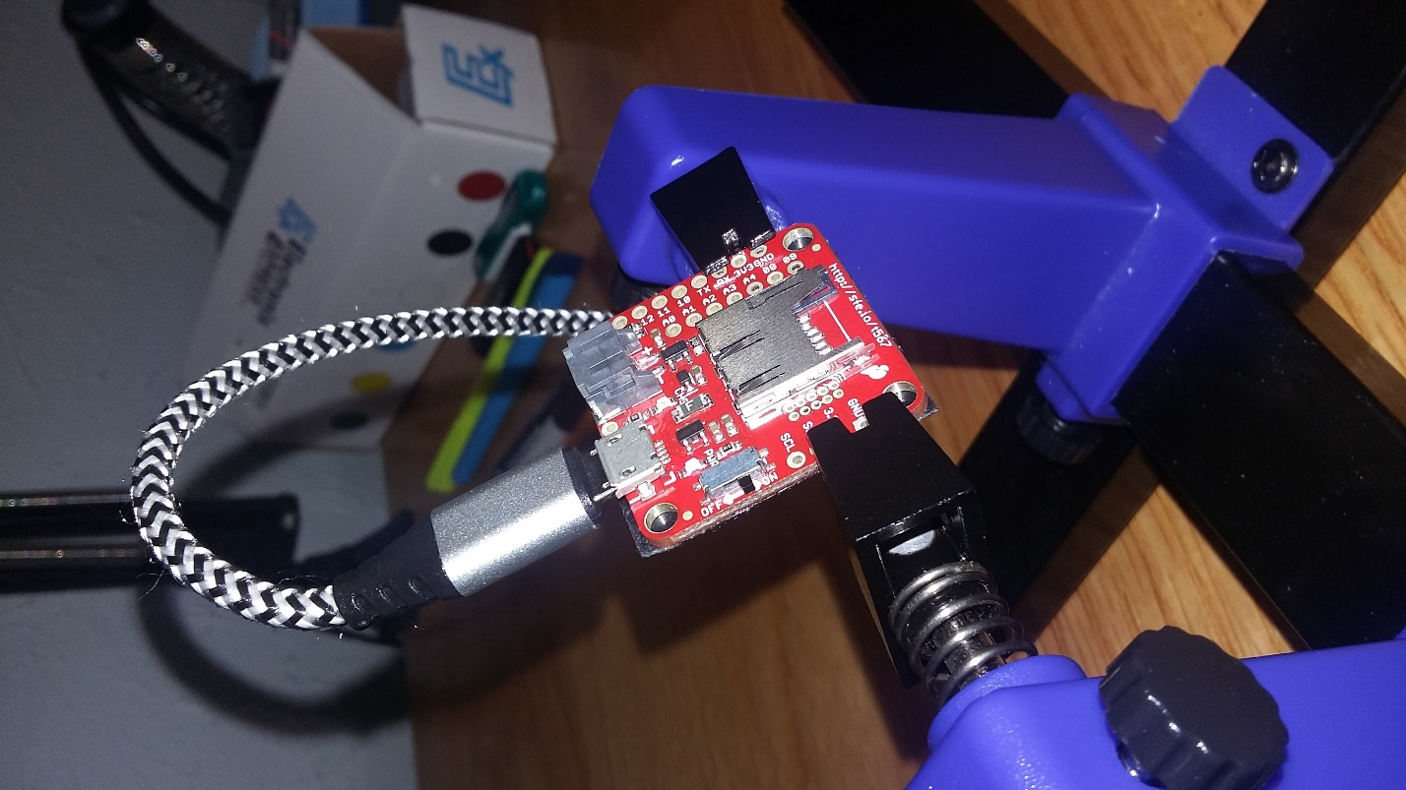

**+Z**

**Fore**

**Sbd**

**Zenith**

**+Y**

**+X**

* 1. Software

For this data collection, the following software version was executed:

|  |  |
| --- | --- |
| Software Title | Sparkfun-9250-9dof-WISE |
| Commit Date | August 4th, 2017 |
| Commit ID | 79091f8e45edf620b3fb0eb5d5ba607786ce9310 |
| Parent Commit ID | 3d098135990e4147b4cabd557e2213bf50be2aa8 |

This version includes Finite Impulse Response (FIR) and Infinite Impulse Response (IIR) filters which could be applied to the input samples (acceleration & gyroscope). However, for this collection these filters were not applied. In general, the acceleration and gyroscope data was unfiltered (raw) before collection, allowing for future algorithms to be developed without the need to account for the effects of these frequency filters.

* 1. Collection Configuration Parameters

There were a total of 7 collection events, 6 static collections and a single (1) walking collection. The collections were as follows:

1. (Duration in data: ~s) F1: Femur Mounted, 1.8 MPH, 15% Incline
2. (Duration in data: ~s) F2: Femur Mounted, 2.7 MPH, 15% Incline
3. (Duration in data: ~s) F3: Femur Mounted, 1.8 MPH, 0% Incline
4. (Duration in data: ~s) F4: Femur Mounted, 2.7 MPH, 0% Incline
5. (Duration in data: ~s) F5: Femur Mounted, 1.8 MPH, -3% Incline
6. (Duration in data: ~s) F6: Femur Mounted, 2.7 MPH, -3% Incline
7. (Duration in data: ~s) S1: Shank Mounted, 1.8 MPH, 15% Incline
8. (Duration in data: ~s) S2: Shank Mounted, 2.7 MPH, 15% Incline
9. (Duration in data: ~s) S3: Shank Mounted, 1.8 MPH, 0% Incline
10. (Duration in data: ~s) S4: Shank Mounted, 2.7 MPH, 0% Incline
11. (Duration in data: ~s) S5: Shank Mounted, 1.8 MPH, -3% Incline
12. (Duration in data: ~s) S6: Shank Mounted, 2.7 MPH, -3% Incline
13. (Duration in data: ~s) Z1: Foot Mounted, 1.8 MPH, 15% Incline
14. (Duration in data: ~s) Z2: Foot Mounted, 2.7 MPH, 15% Incline
15. (Duration in data: ~s) Z3: Foot Mounted, 1.8 MPH, 0% Incline
16. (Duration in data: ~s) Z4: Foot Mounted, 2.7 MPH, 0% Incline
17. (Duration in data: ~s) Z5: Foot Mounted, 1.8 MPH, -3% Incline
18. (Duration in data: ~s) Z6: Foot Mounted, 2.7 MPH, -3% Incline
19. Results

The analysis here is limited to the raw outputs of the sensors (6 axis) and DCM estimation. Further updates will include the Vicon 3D positioning data which will be used to get a rough accuracy estimation of the DCM outputs.

* 1. **F1: Femur Mounted, 1.8 MPH, 15% Incline**

**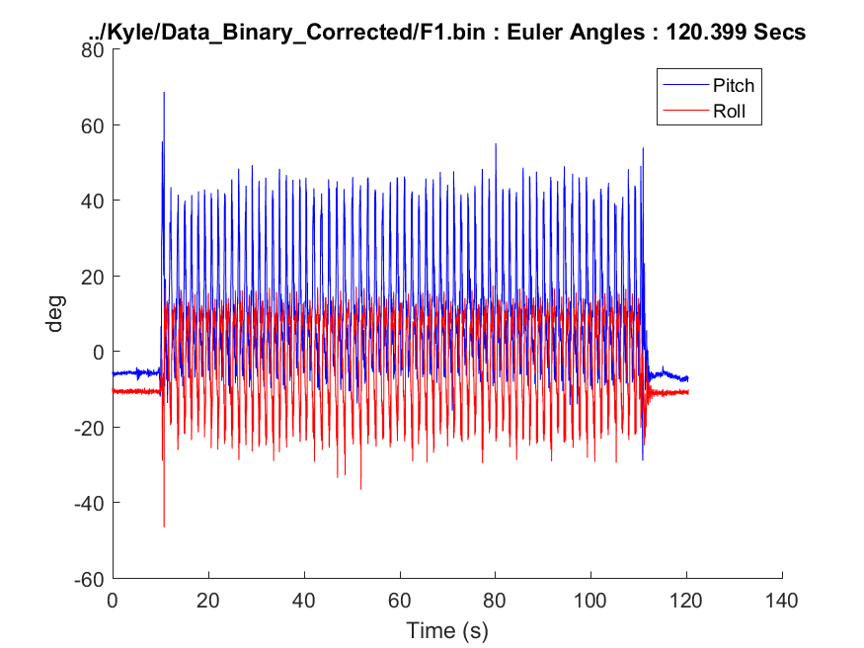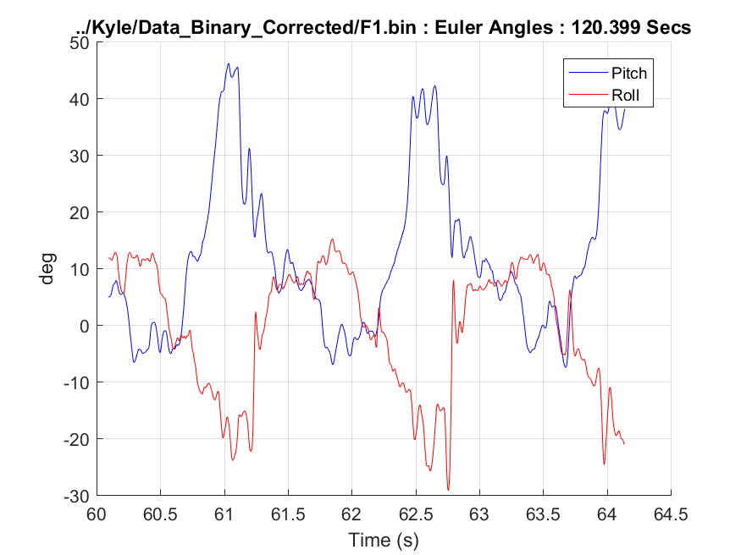  
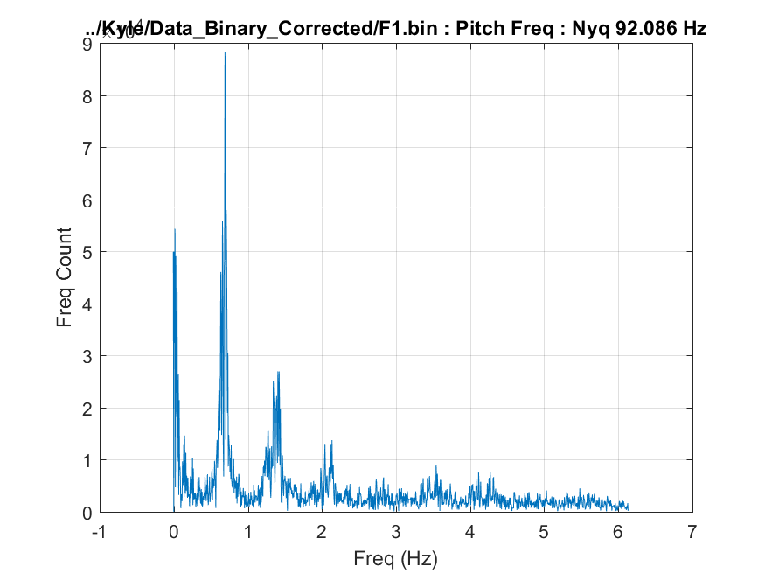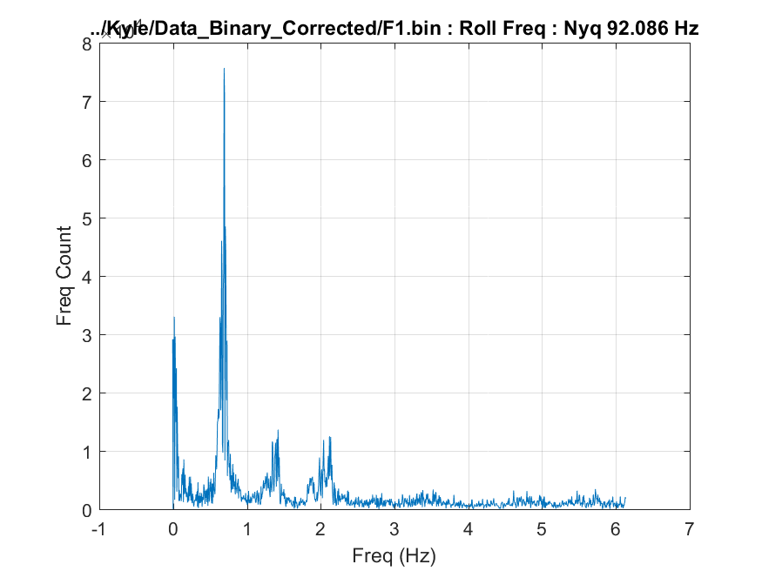**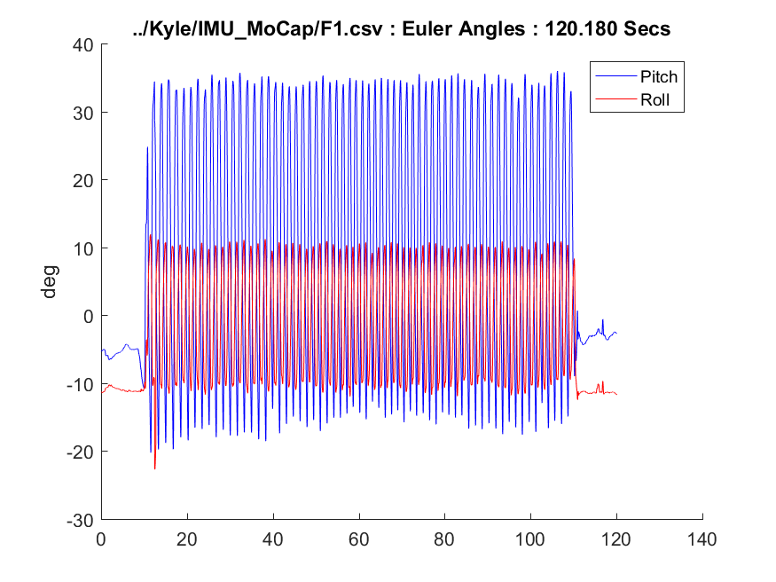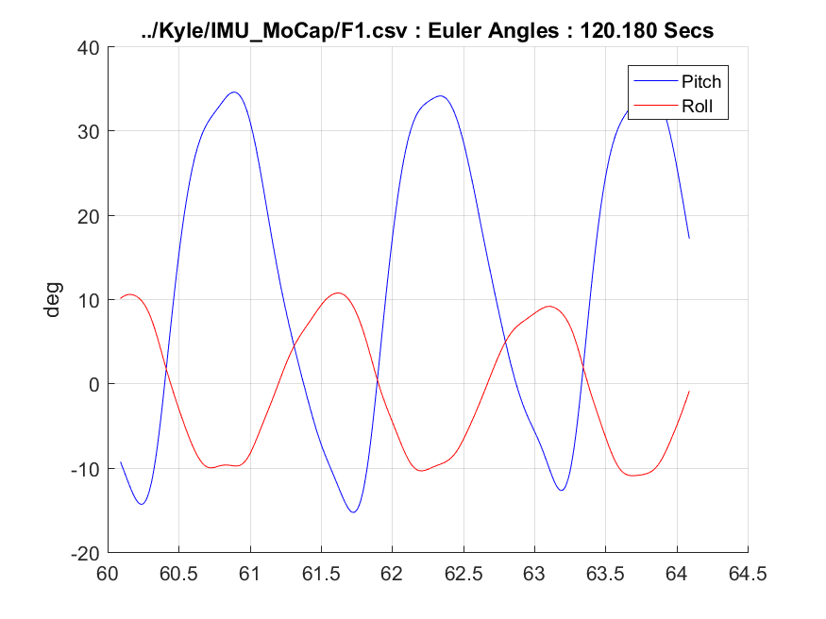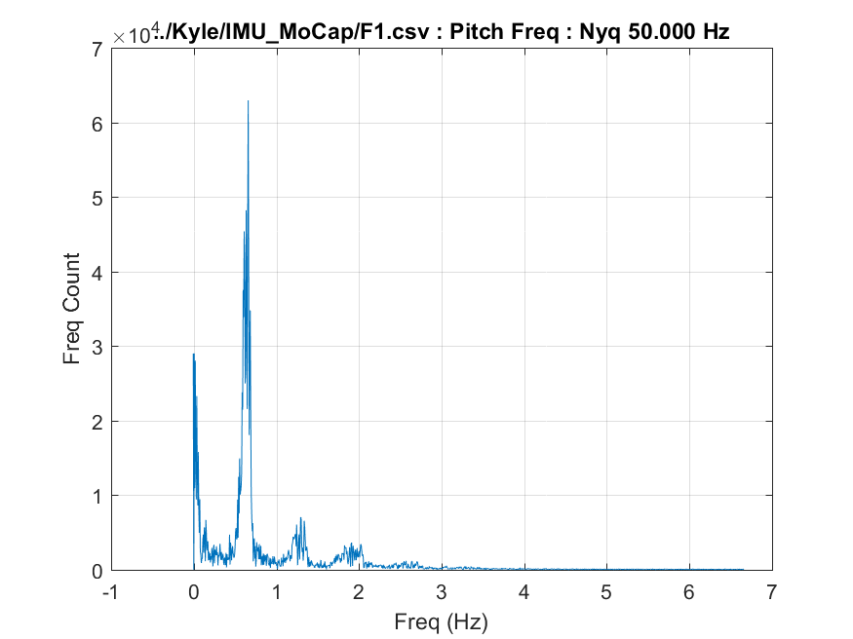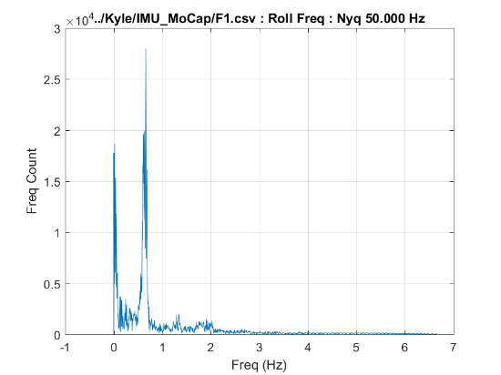

* 1. **F2: Femur Mounted, 2.7 MPH, 15% Incline**

**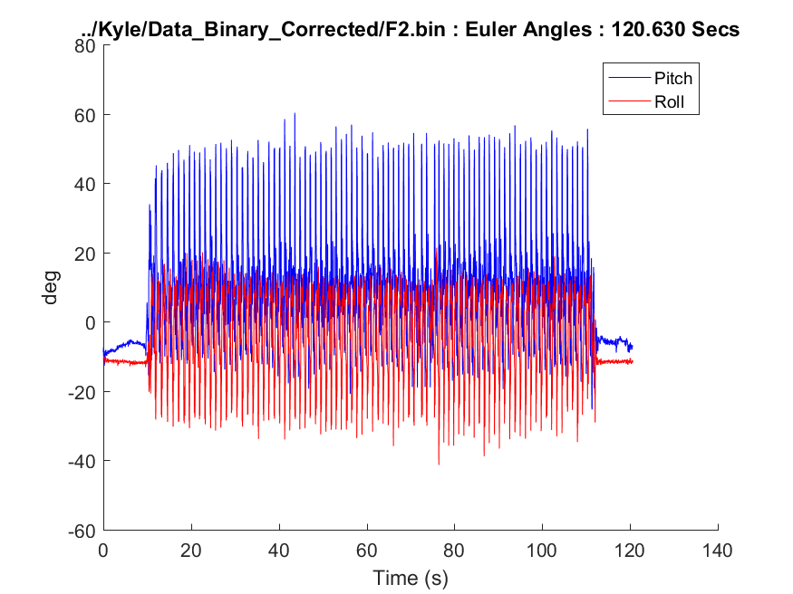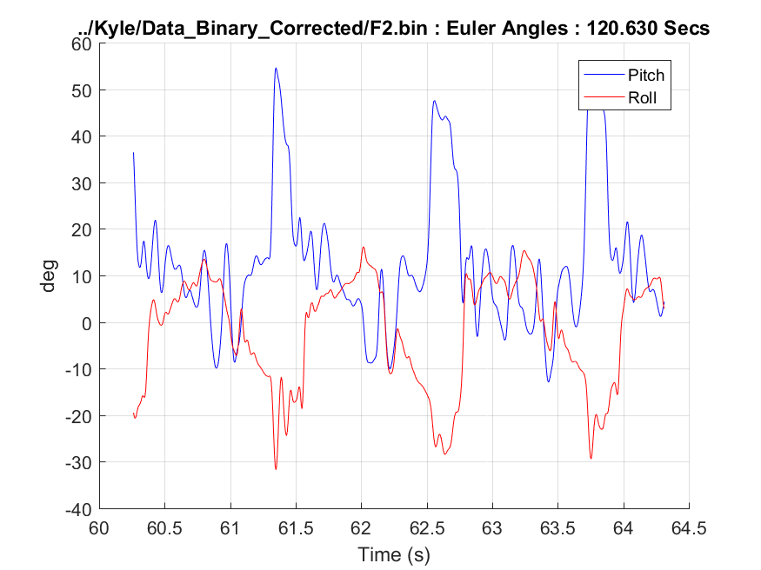  
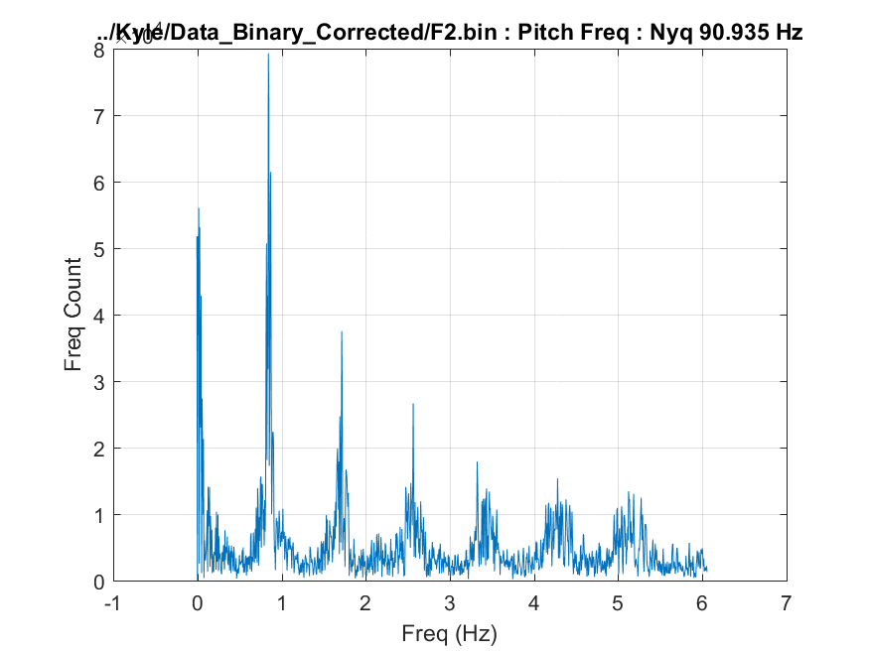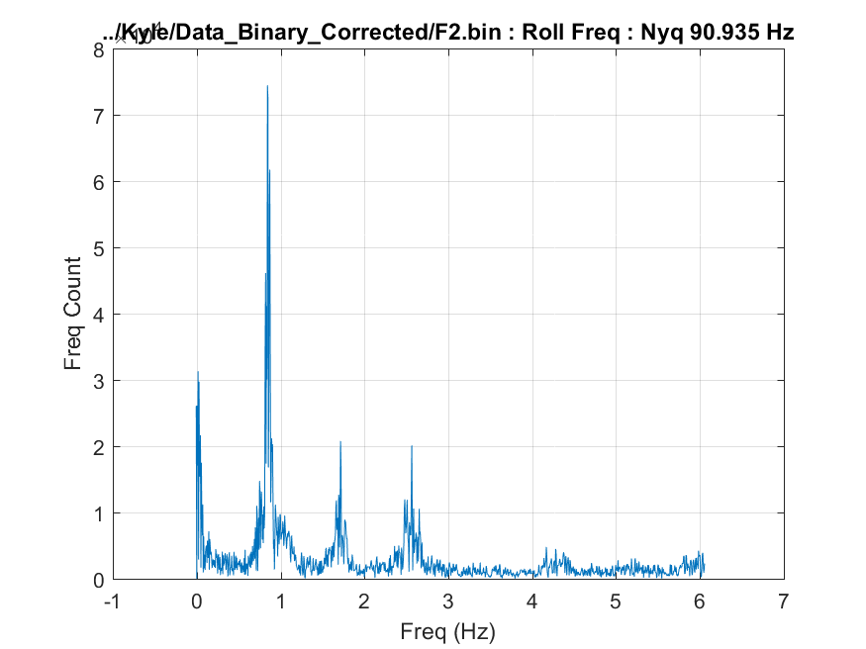**

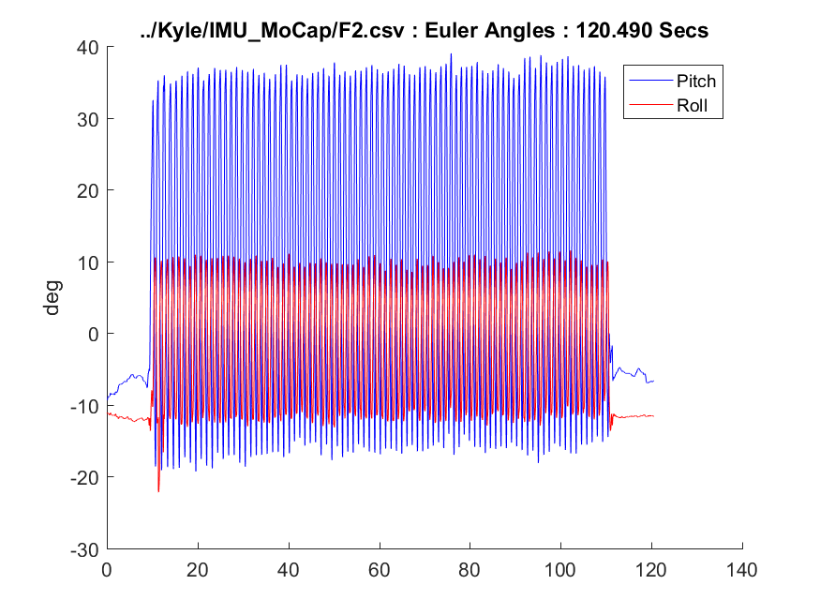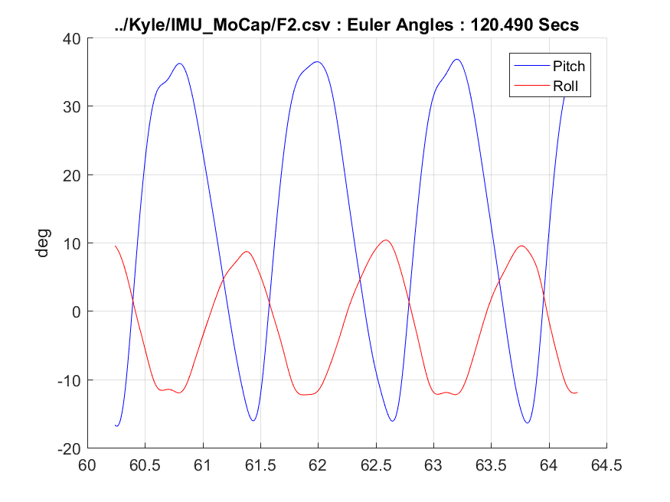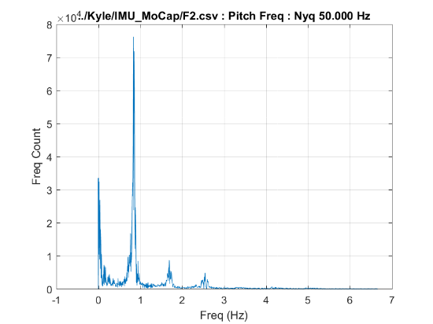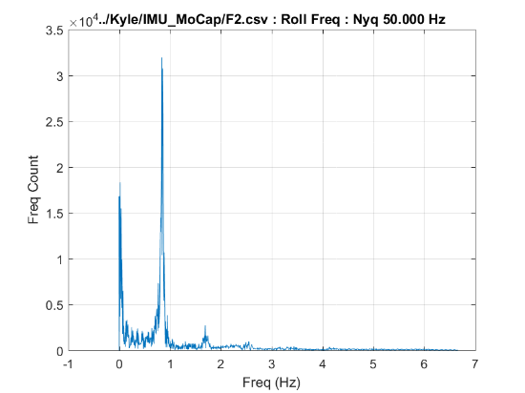

* 1. **F3: Femur Mounted, 1.8 MPH, 0% Incline**

**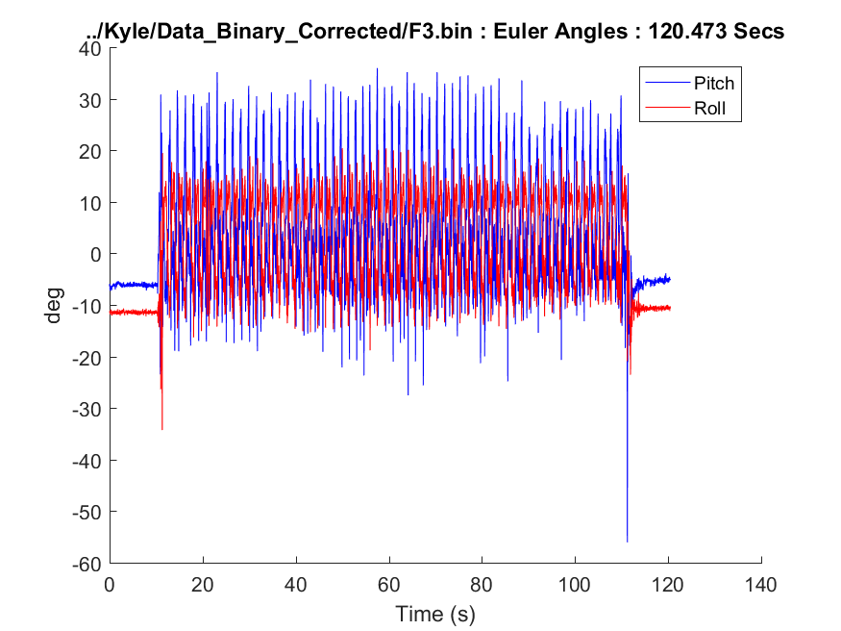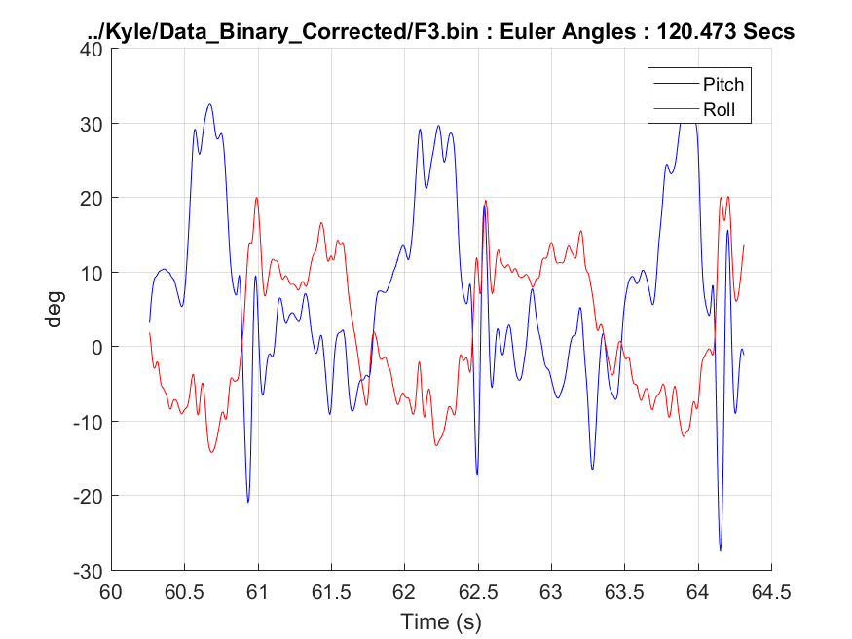  
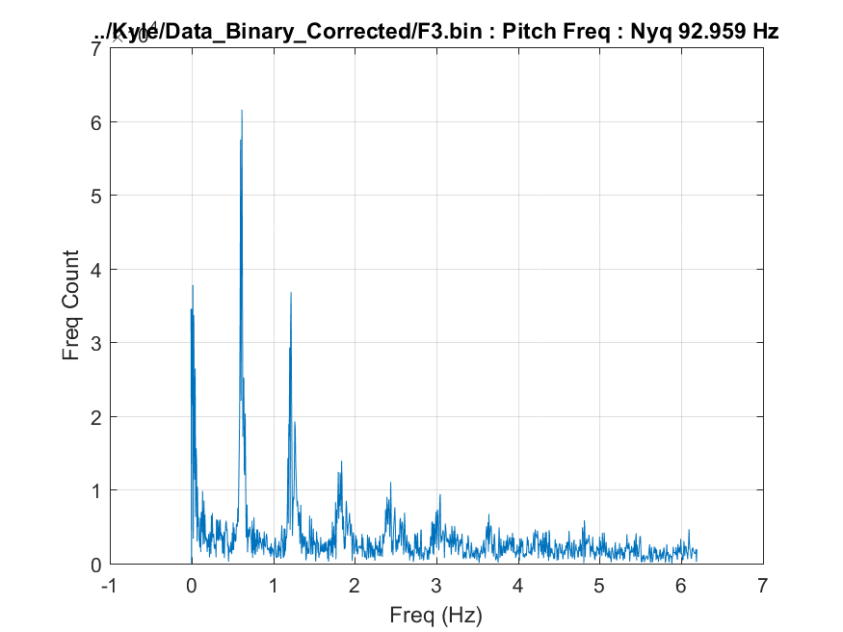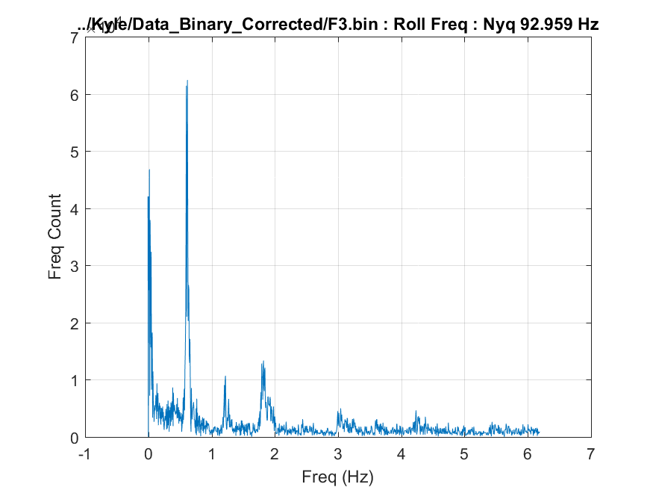**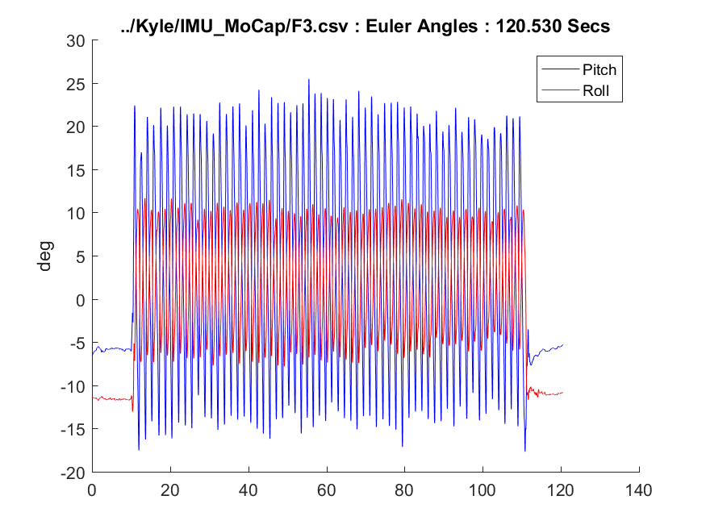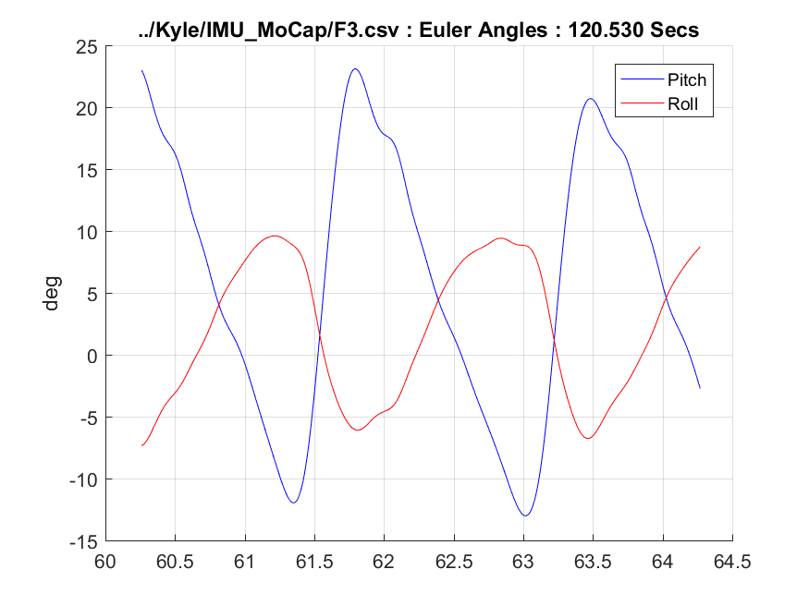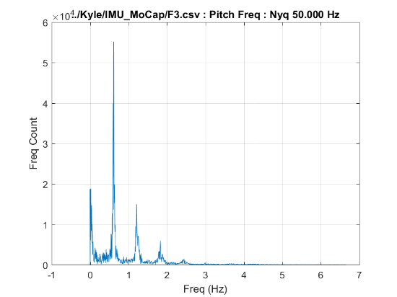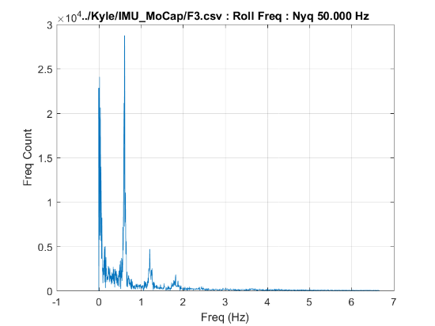

* 1. **F4: Femur Mounted, 2.7 MPH, 0% Incline**

**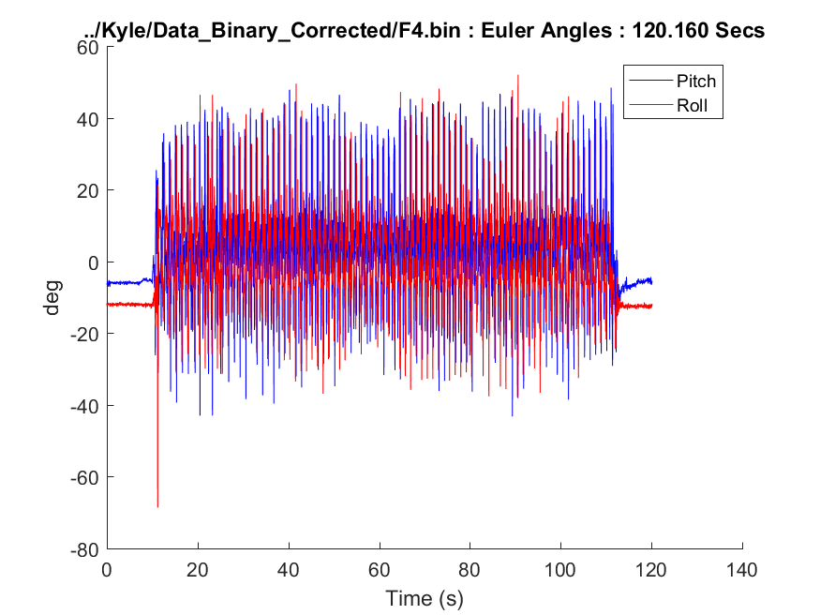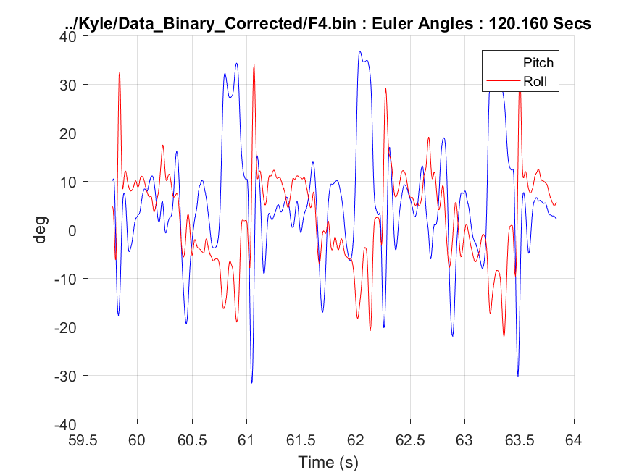  
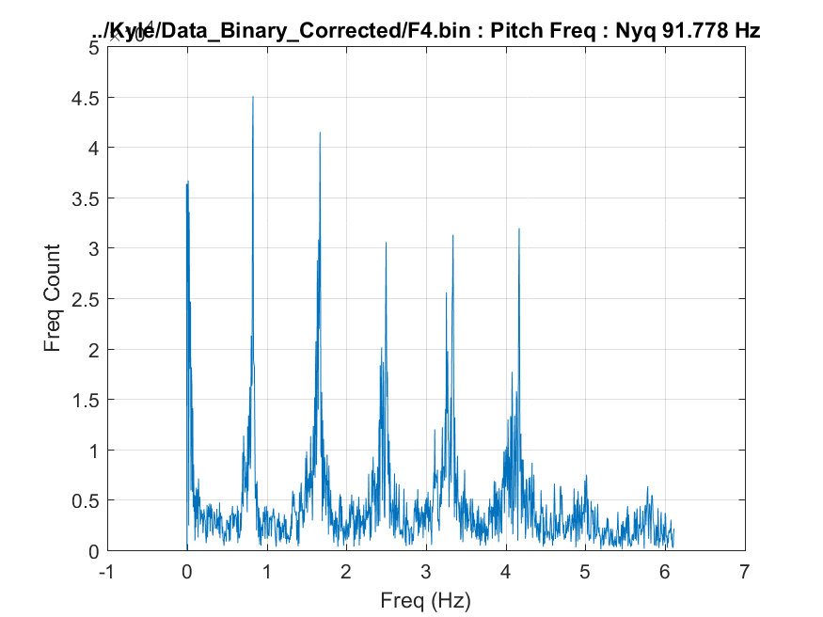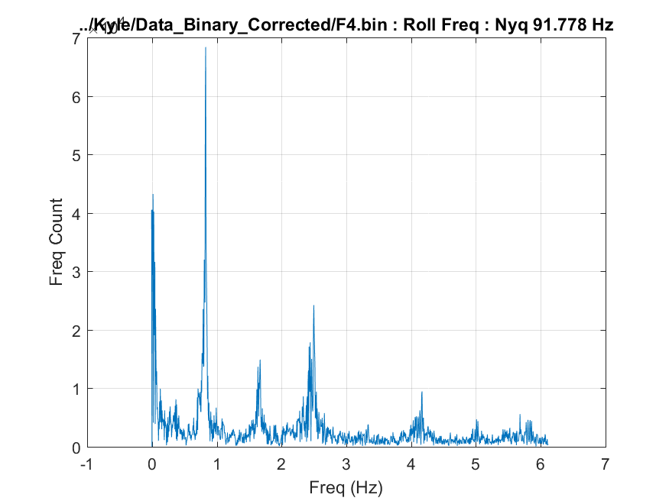**

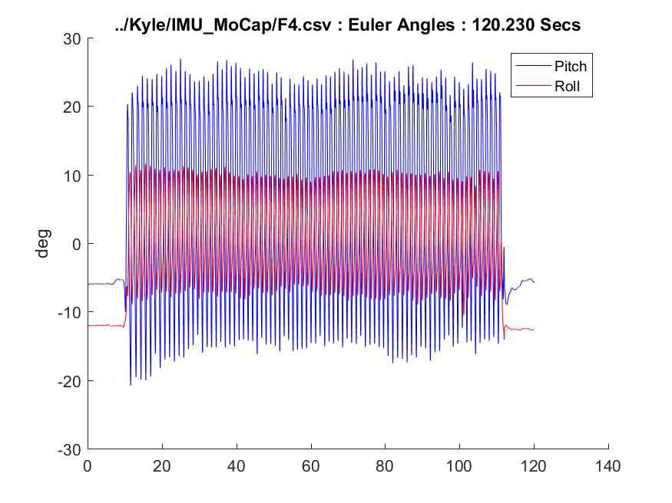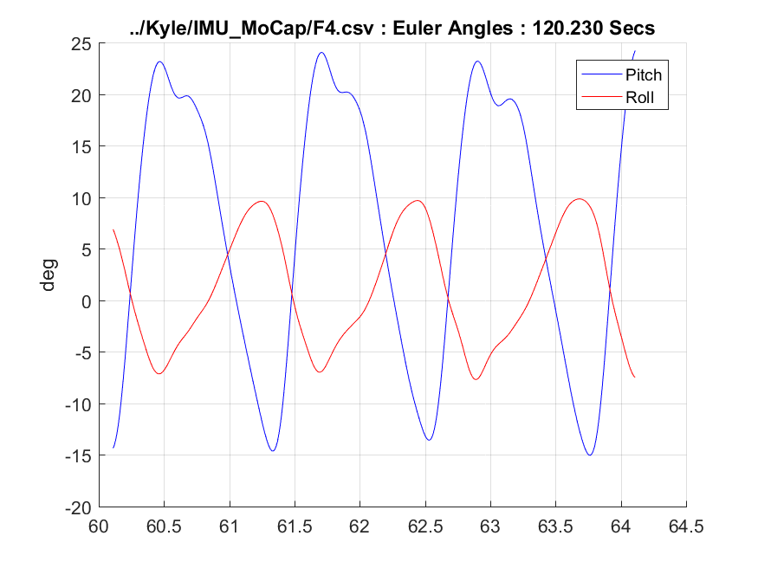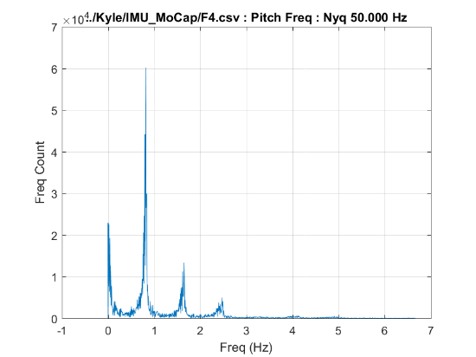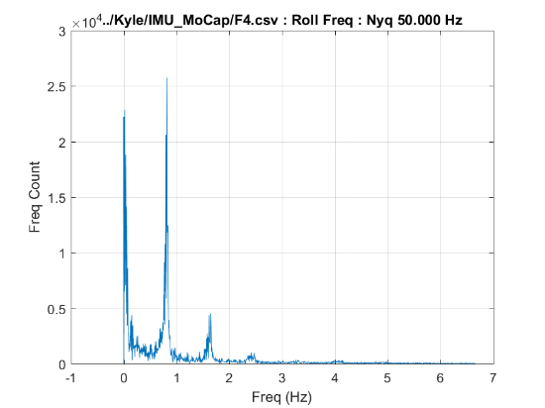

* 1. **F5: Femur Mounted, 1.8 MPH, -3% Incline**

**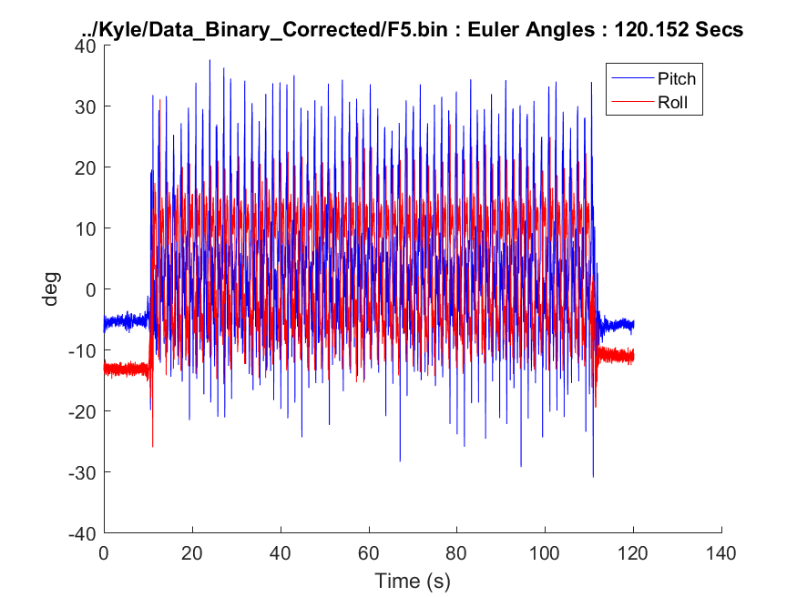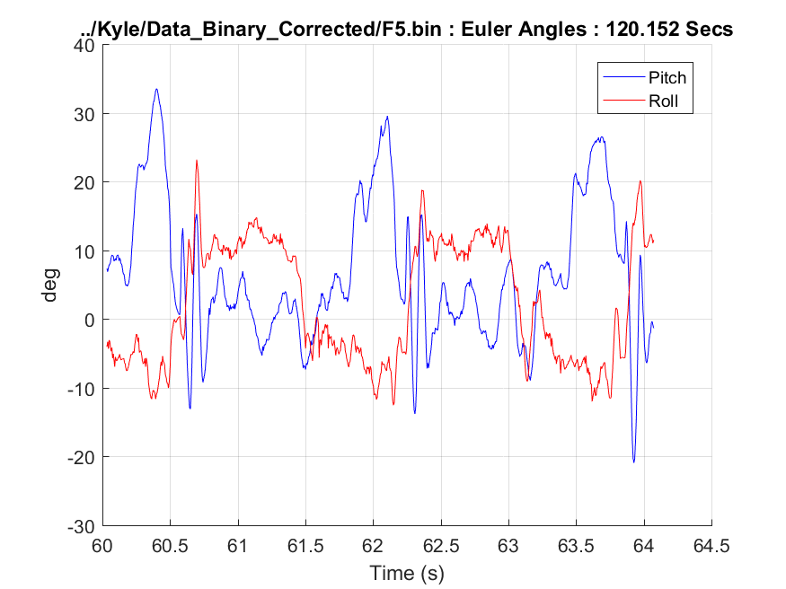  
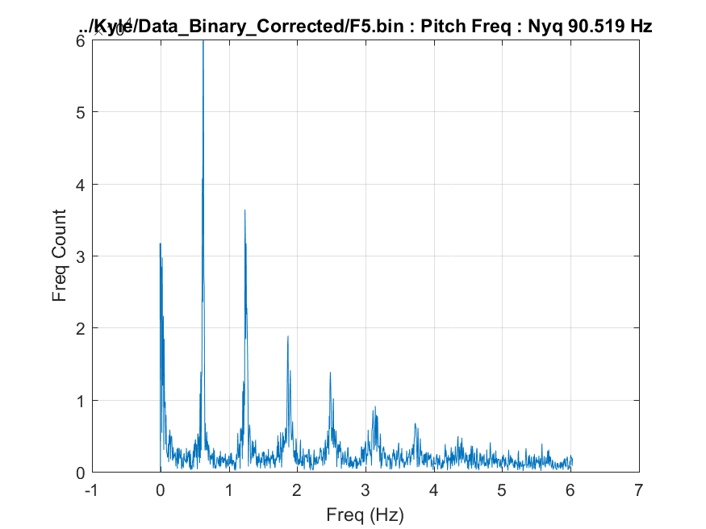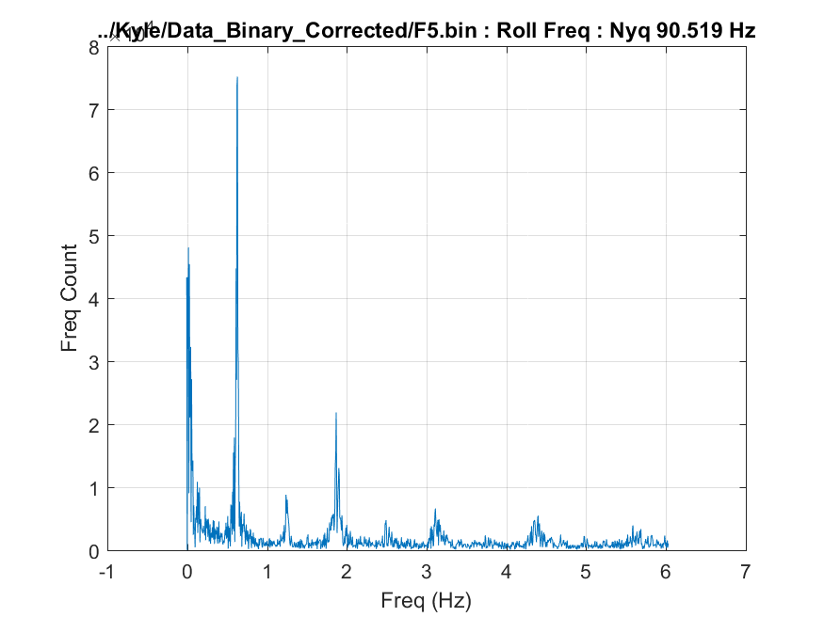**

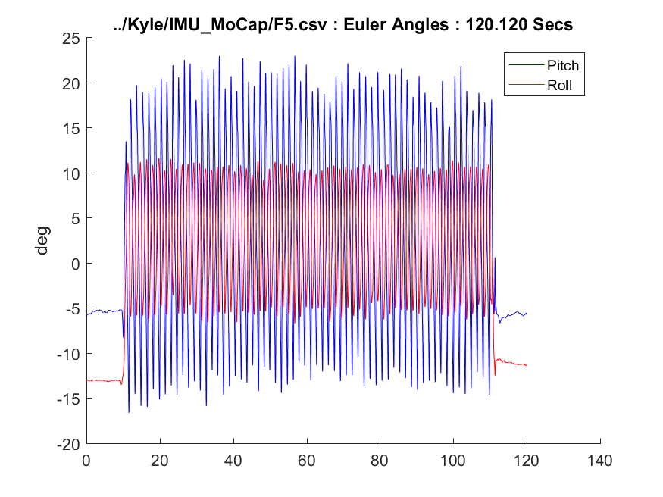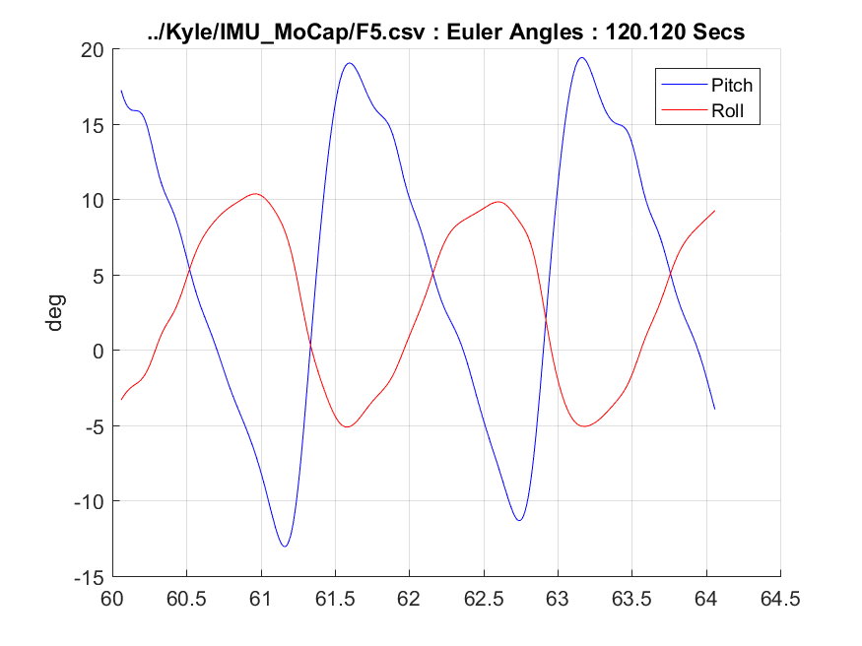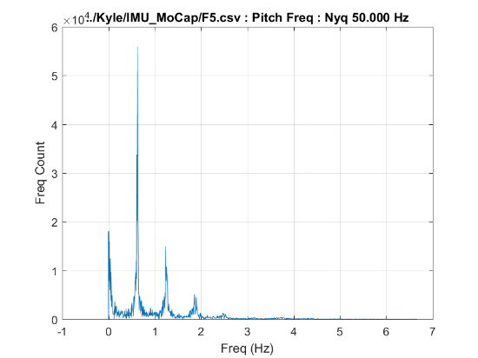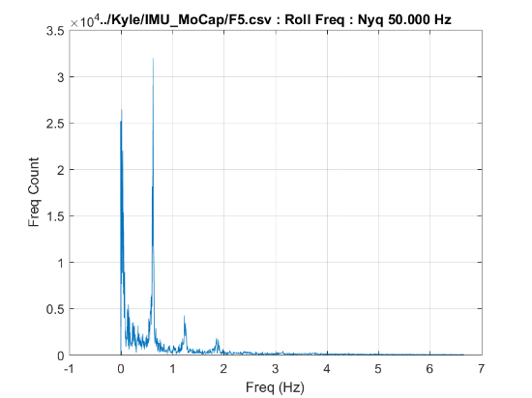

* 1. **F6: Femur Mounted, 2.7 MPH, -3% Incline**

**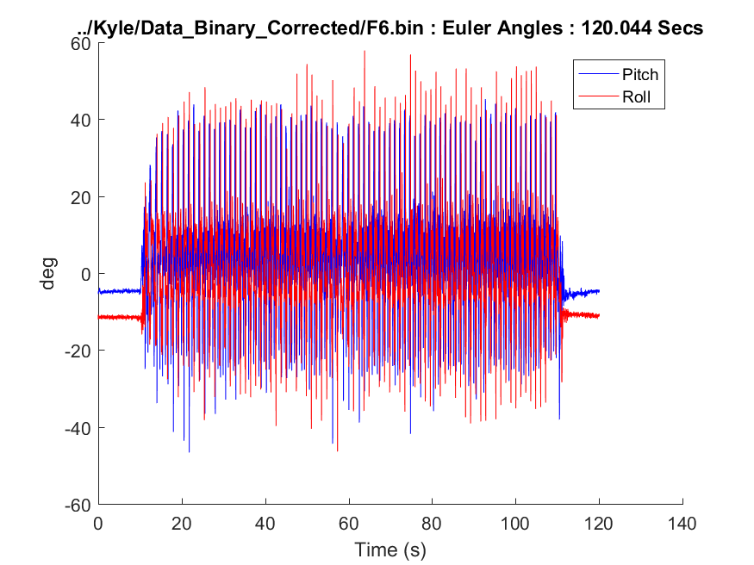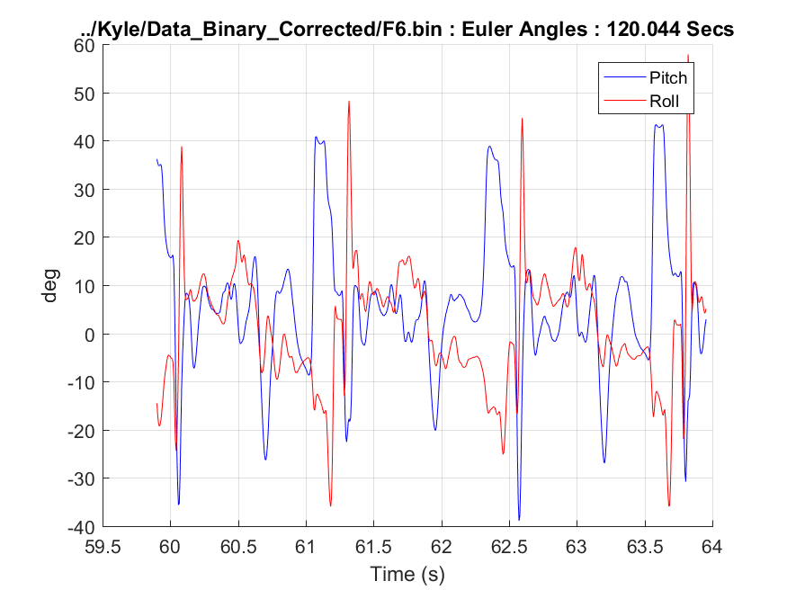  
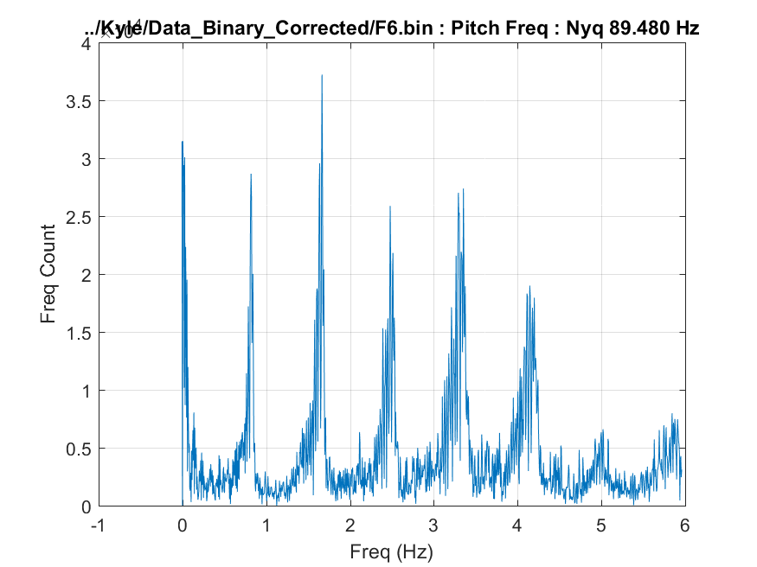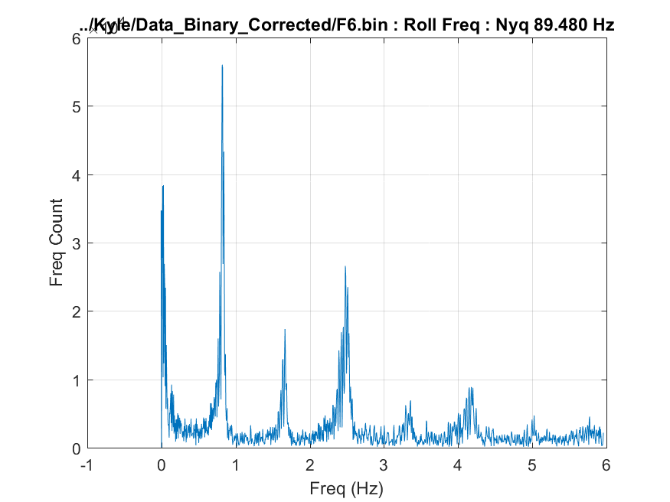**

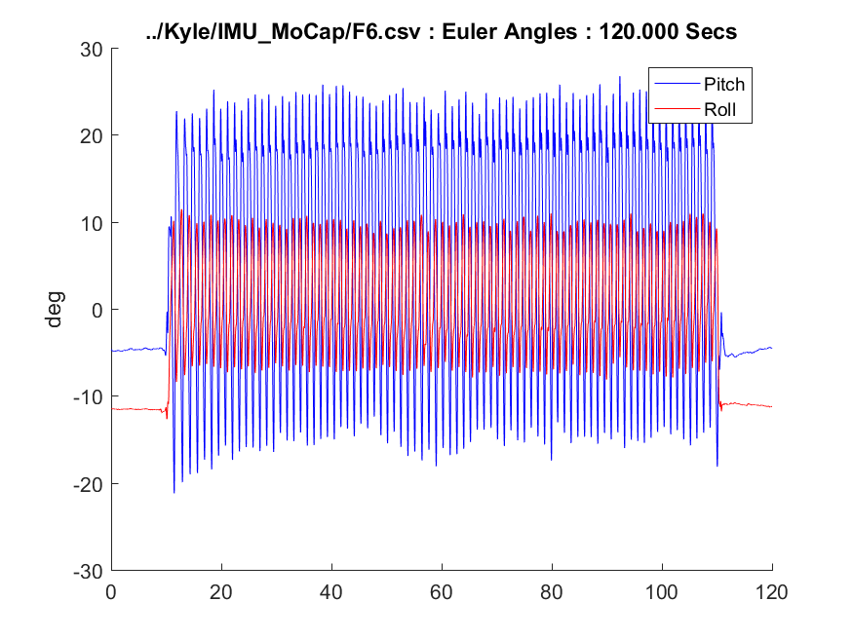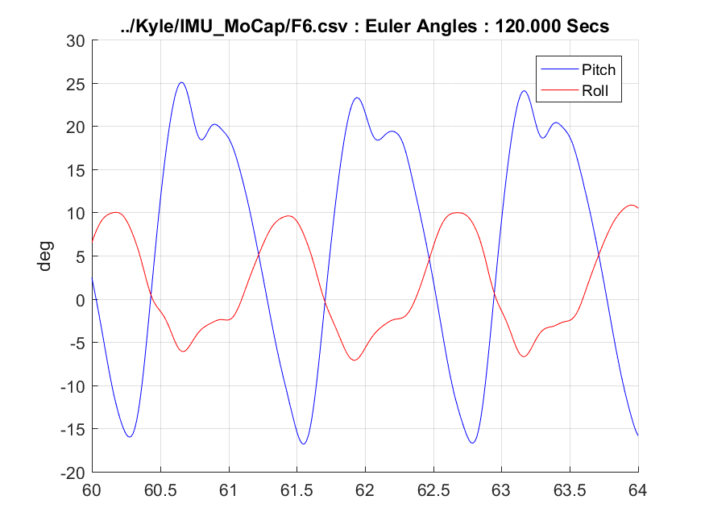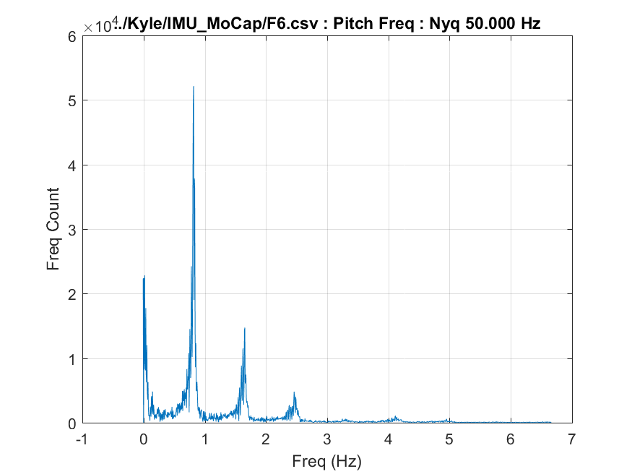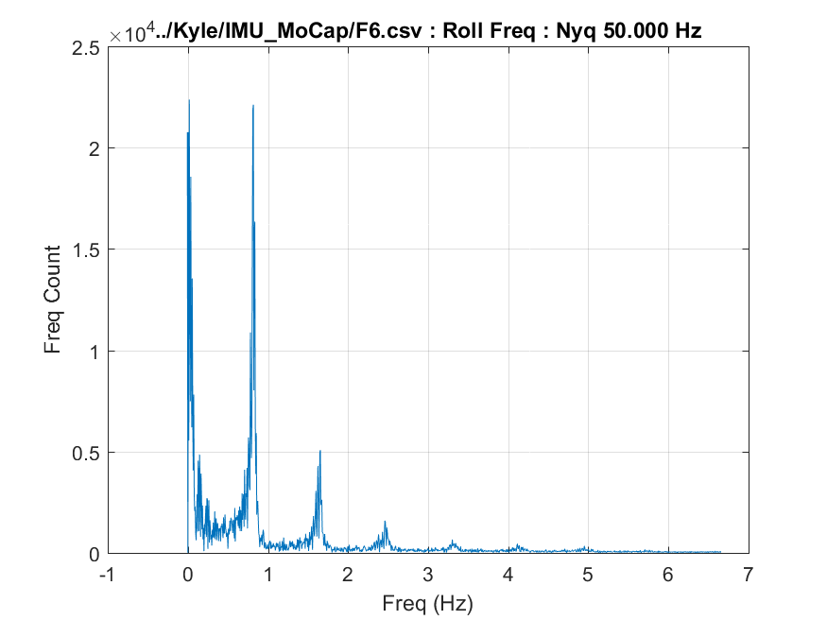

* 1. **S1: Shank Mounted, 1.8 M PH, 15% Incline**

**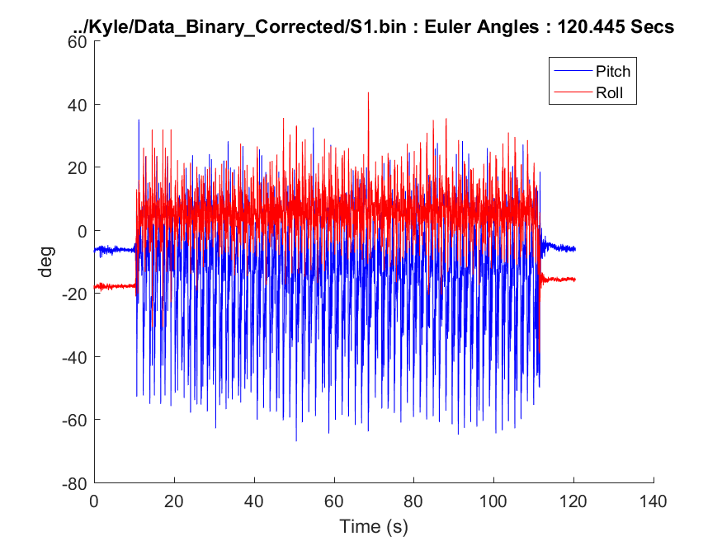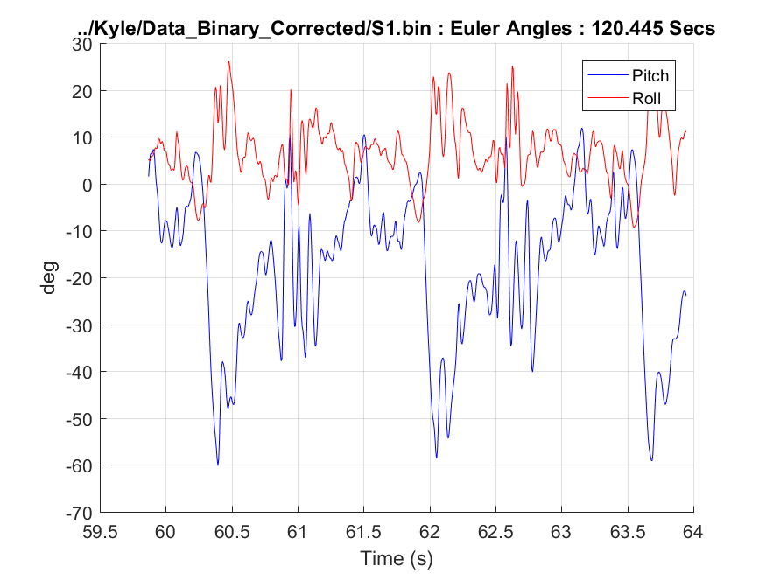  
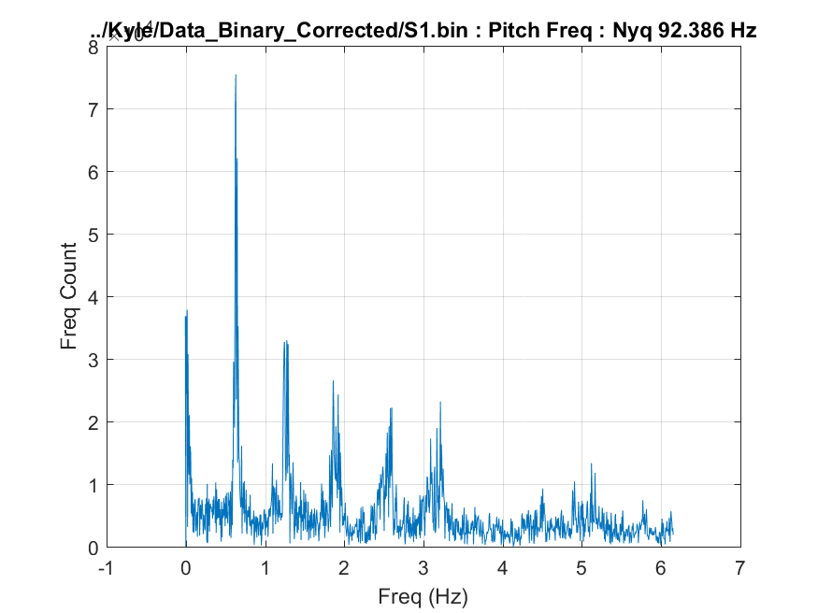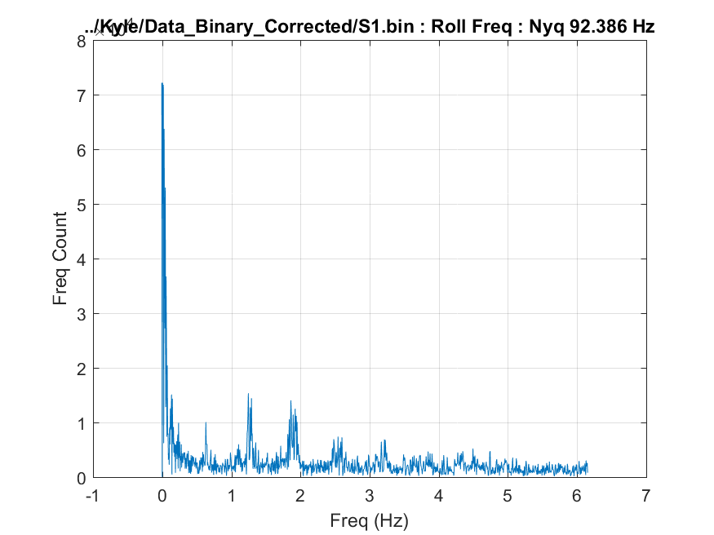**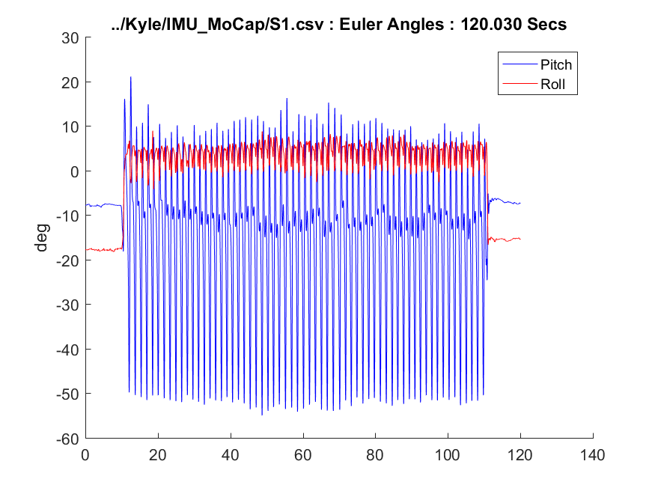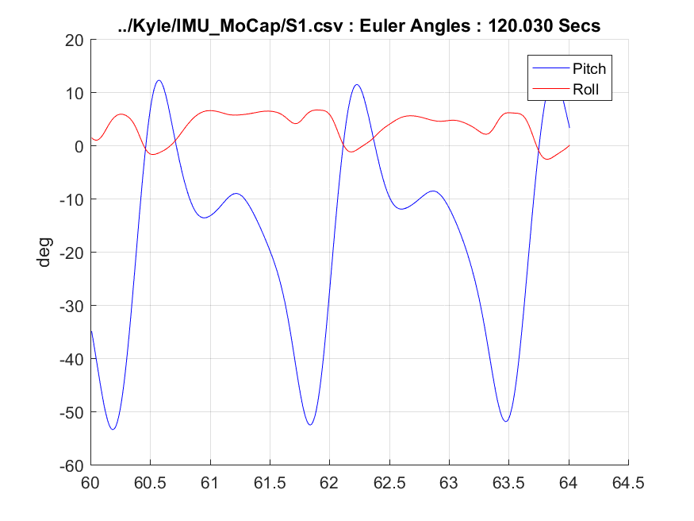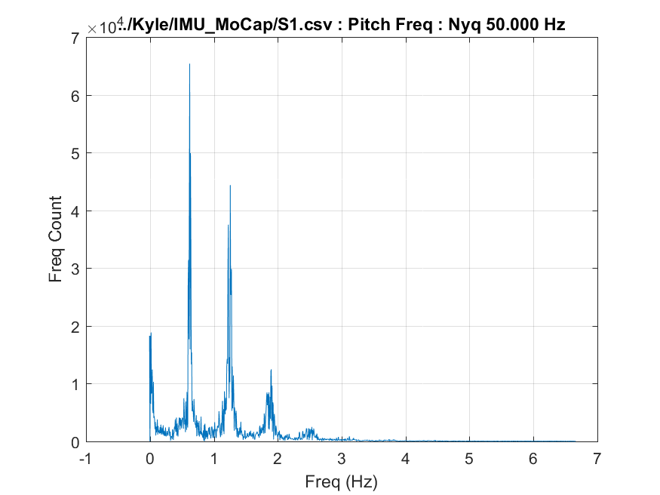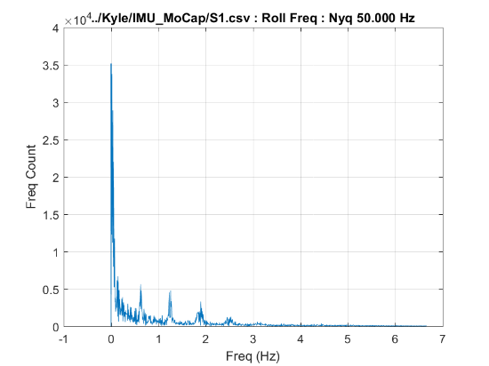

* 1. **S2: Shank Mounted, 2.7 MPH, 15% Incline**

**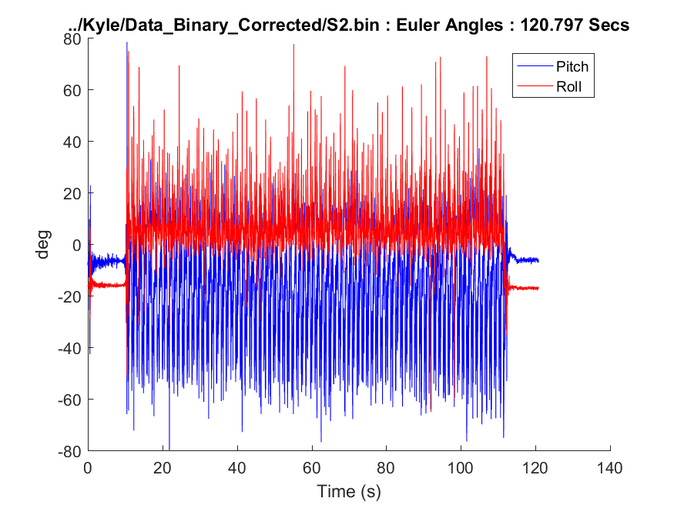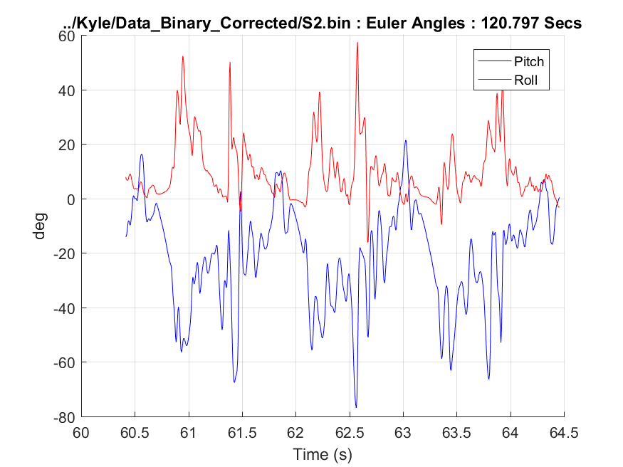  
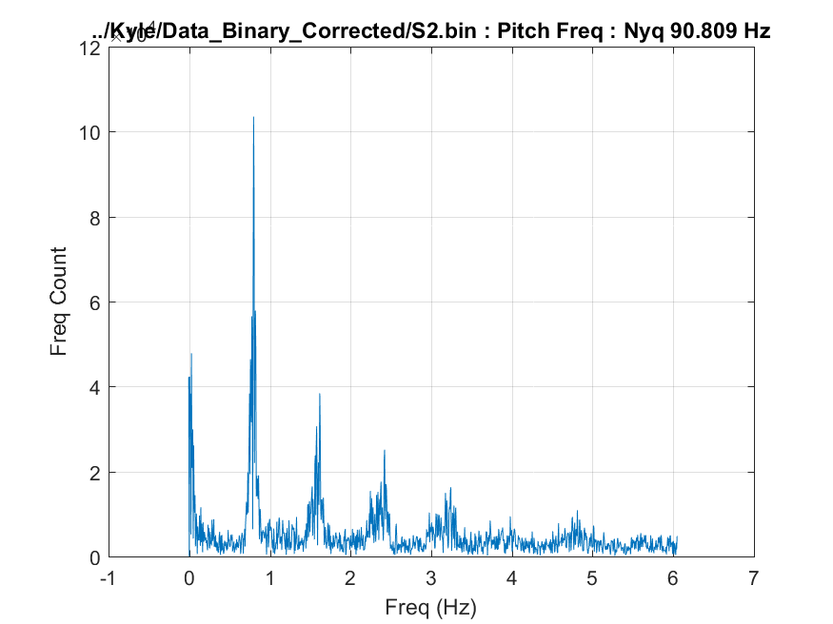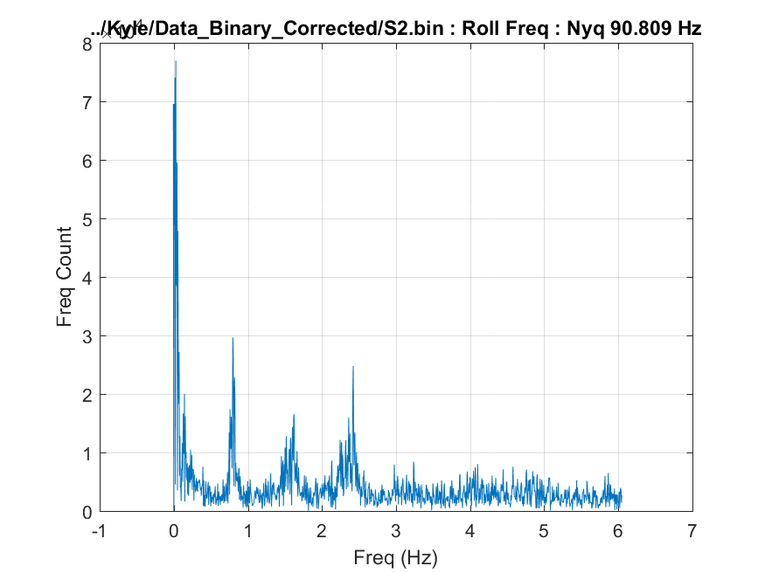**

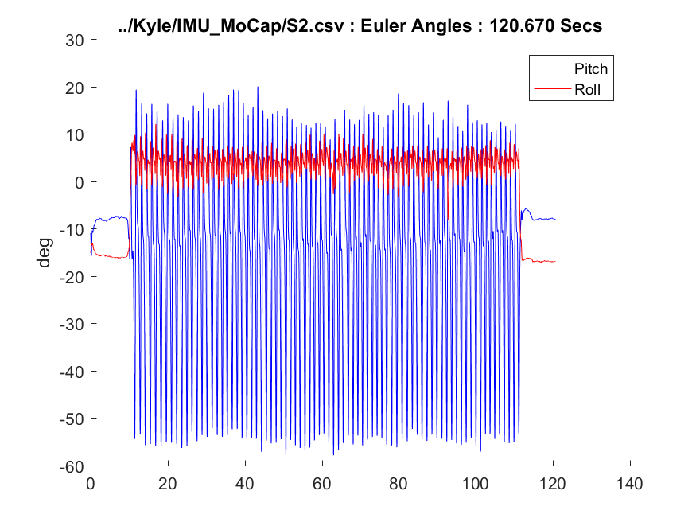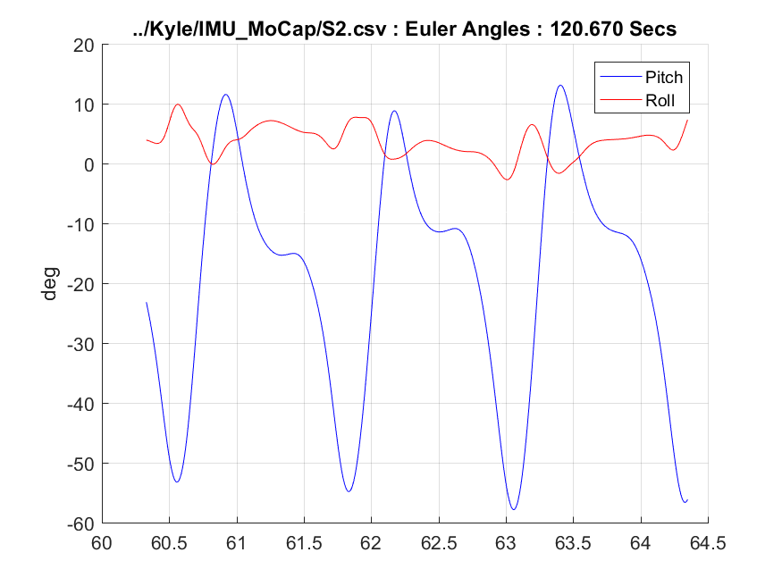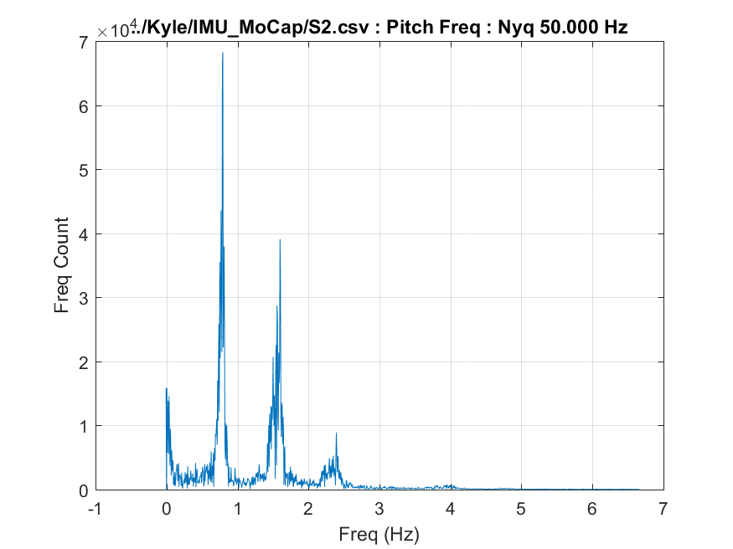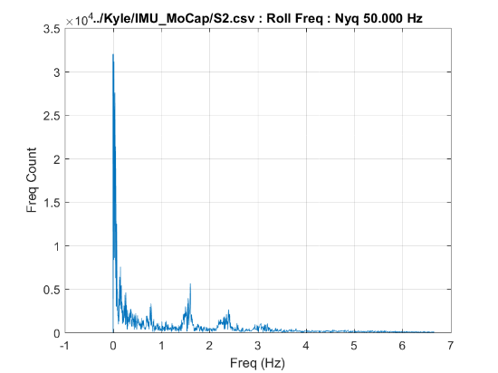

* 1. **S3: Shank Mounted, 1.8 MPH, 0% Incline**

**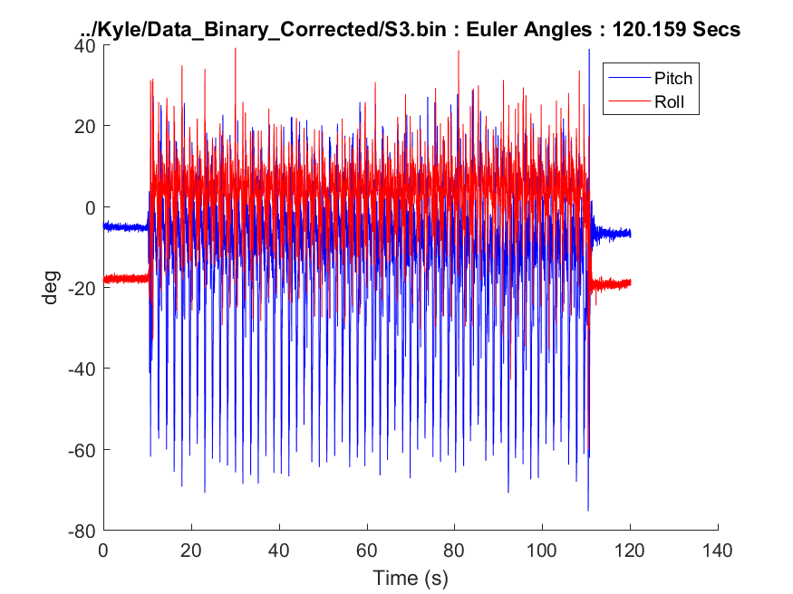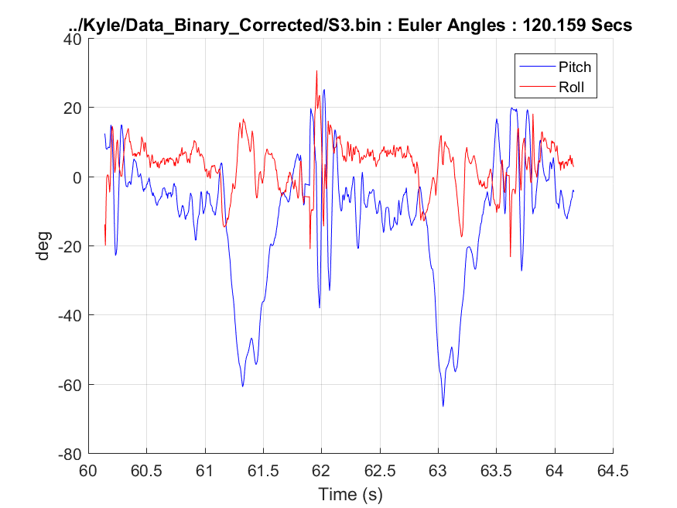  
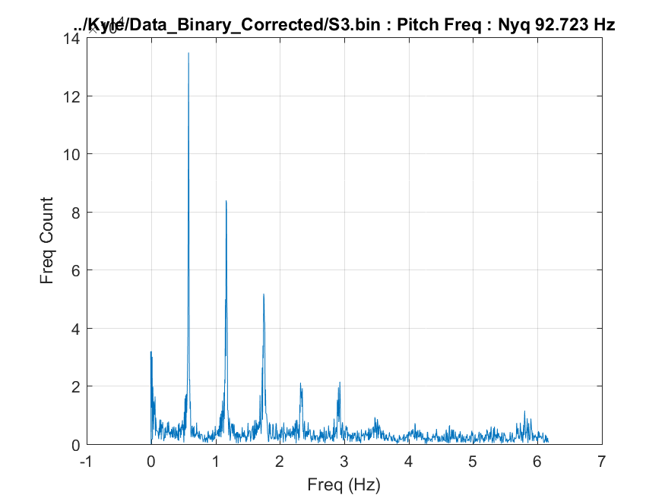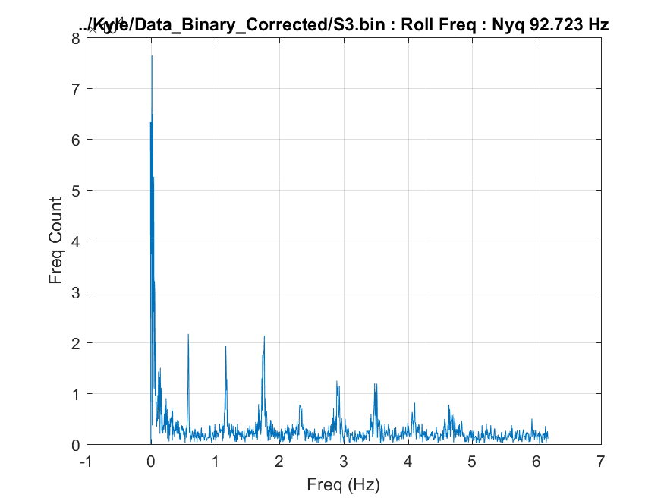**

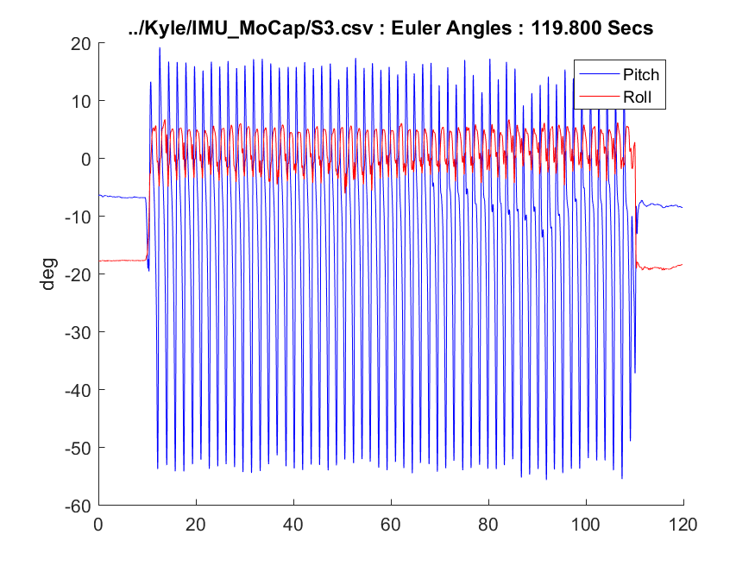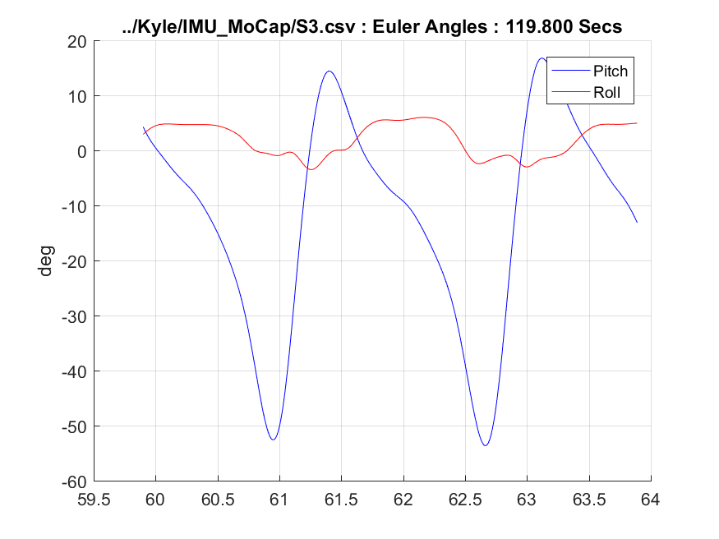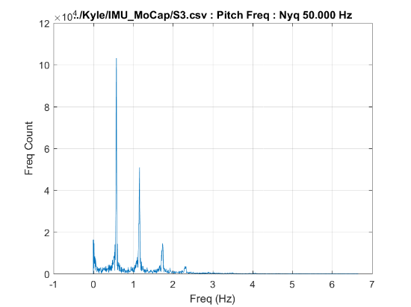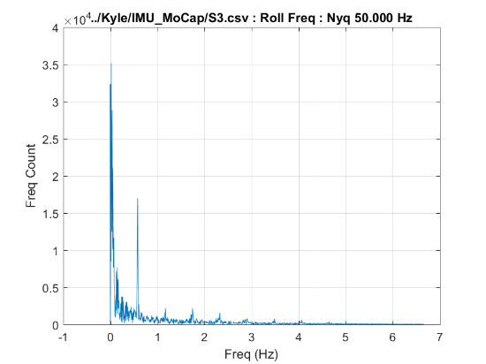

* 1. **S4: Shank Mounted, 2.7 MPH, 0% Incline**

**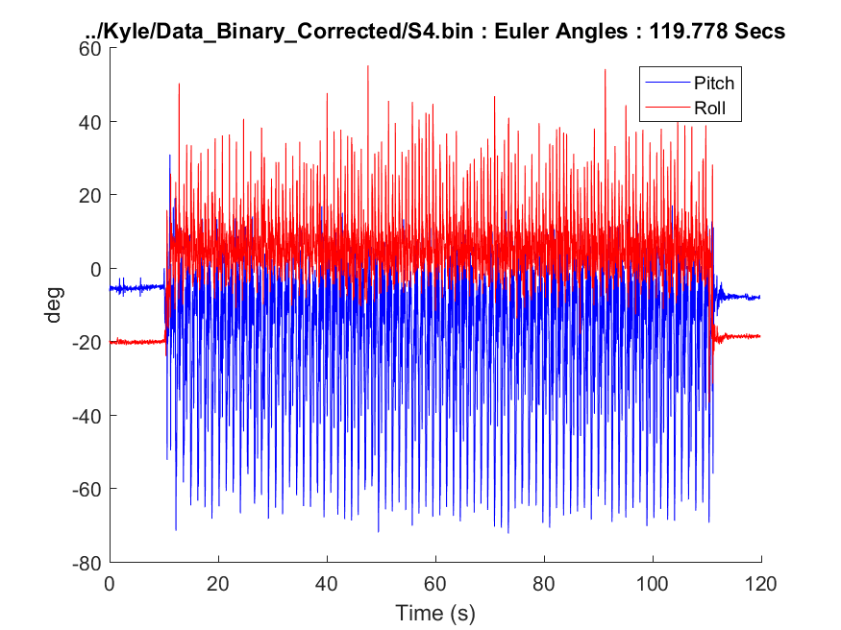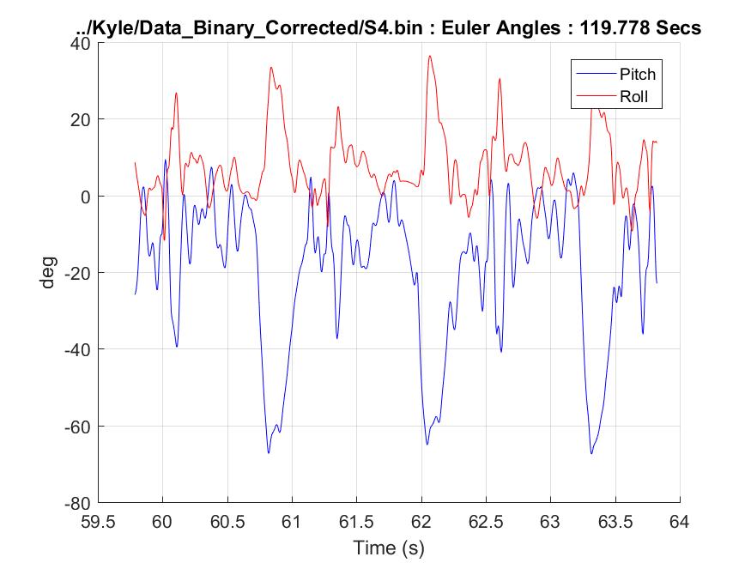  
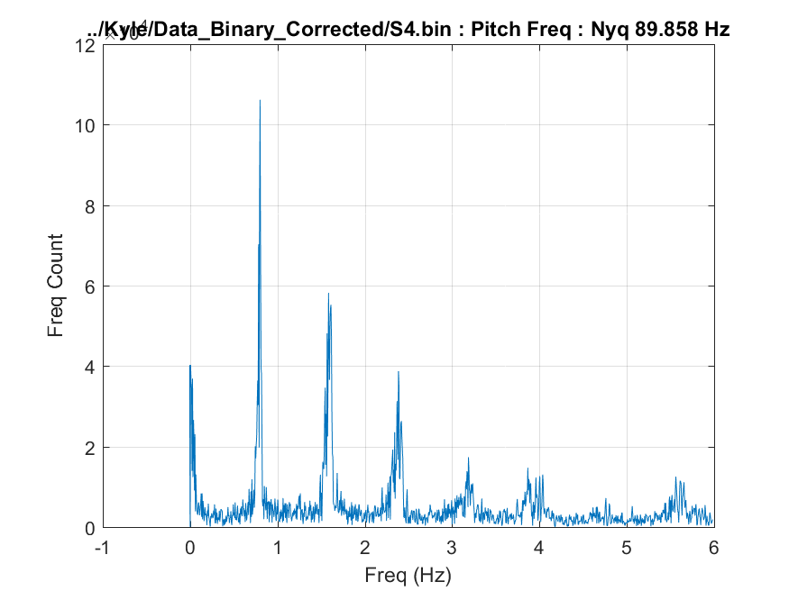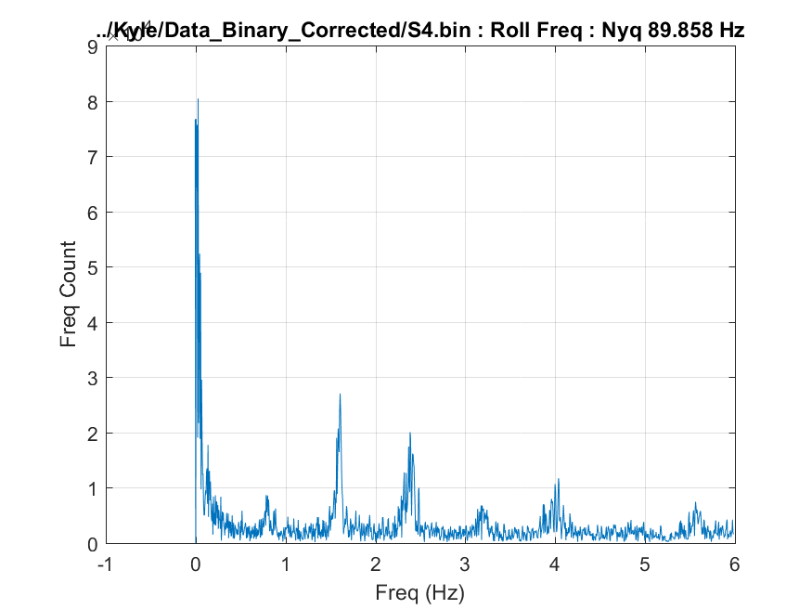**

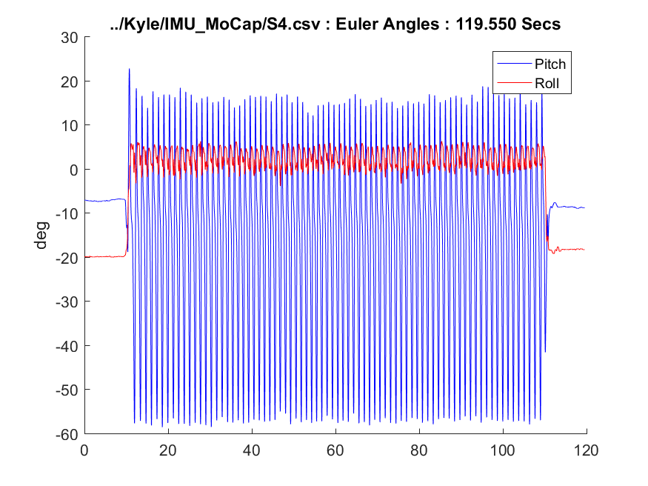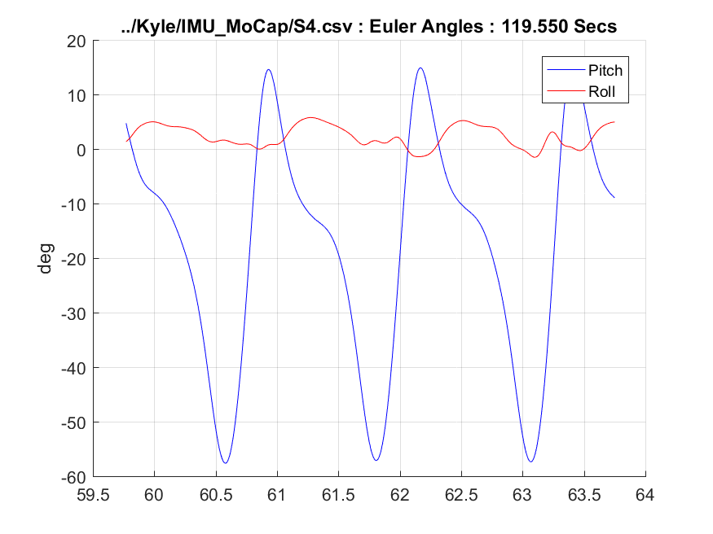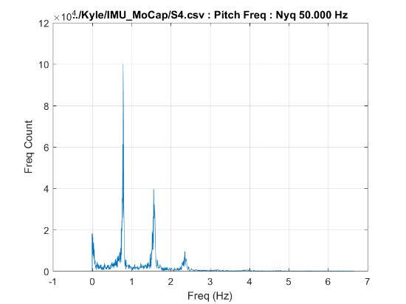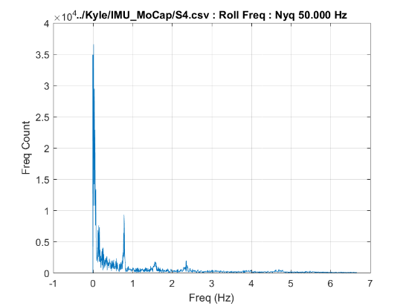

* 1. **S5: Shank Mounted, 1.8 MPH, -3% Incline**

**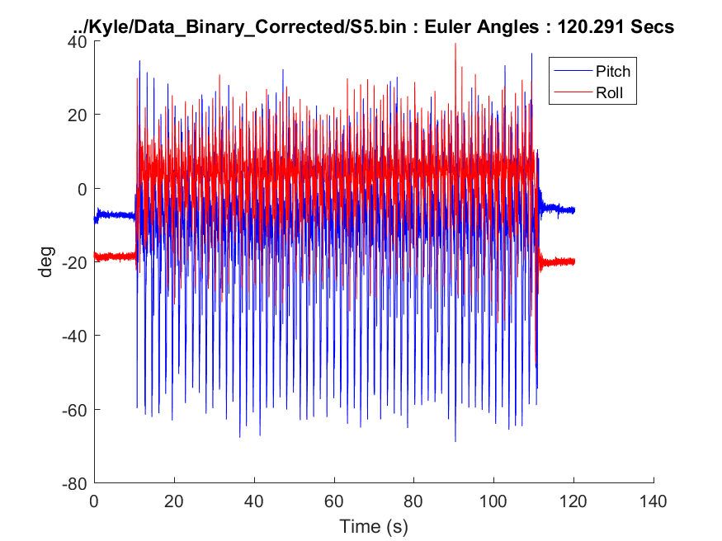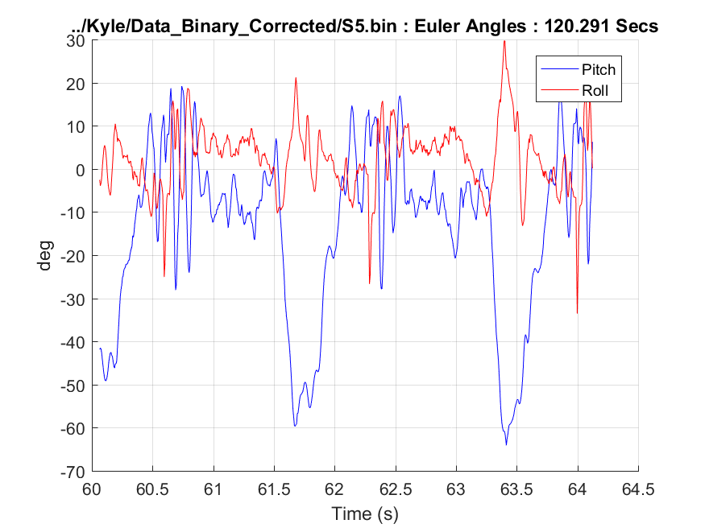  
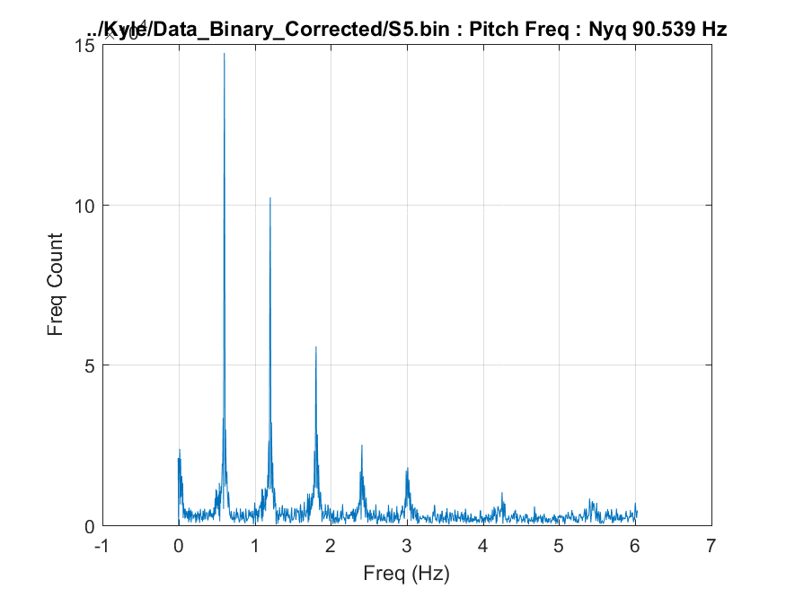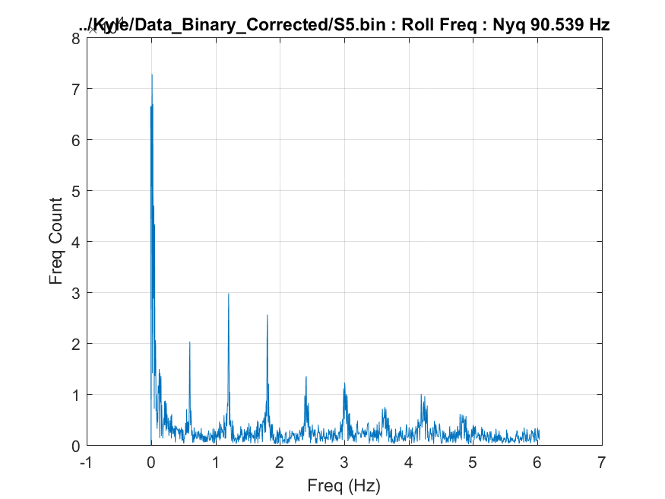**

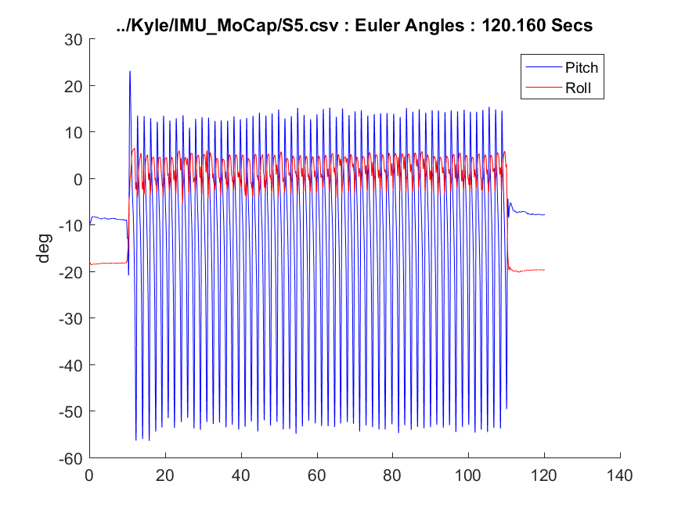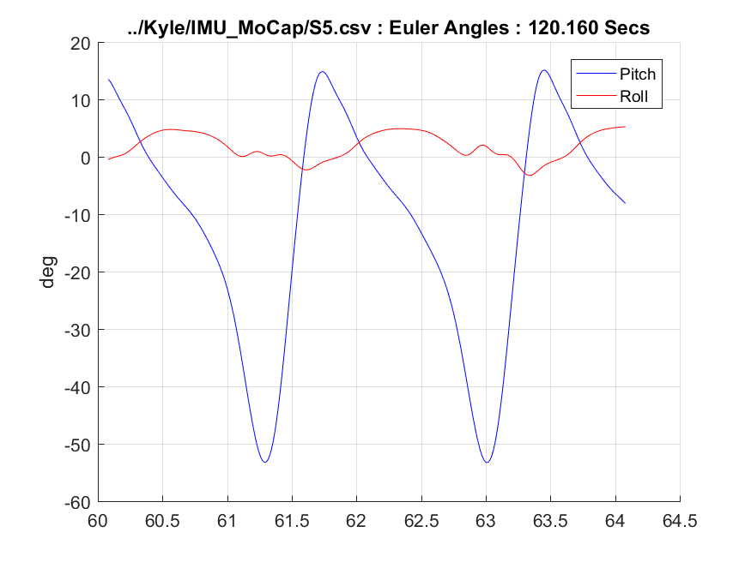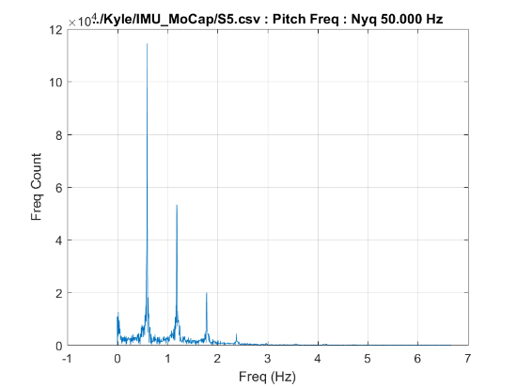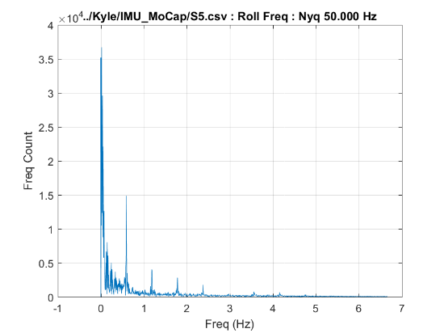

* 1. **S6: Shank Mounted, 2.7 MPH, -3% Incline**

**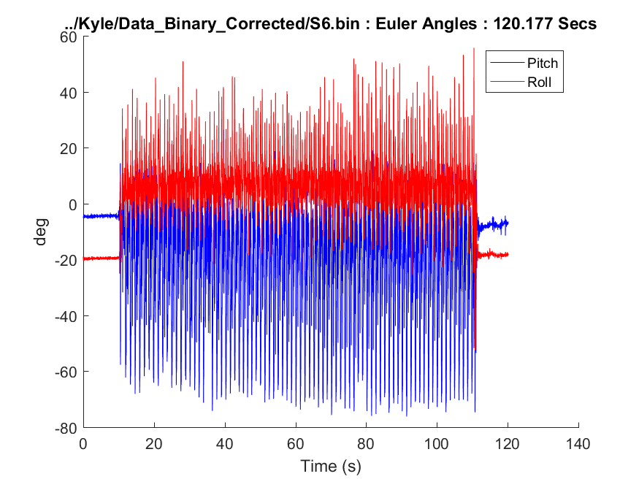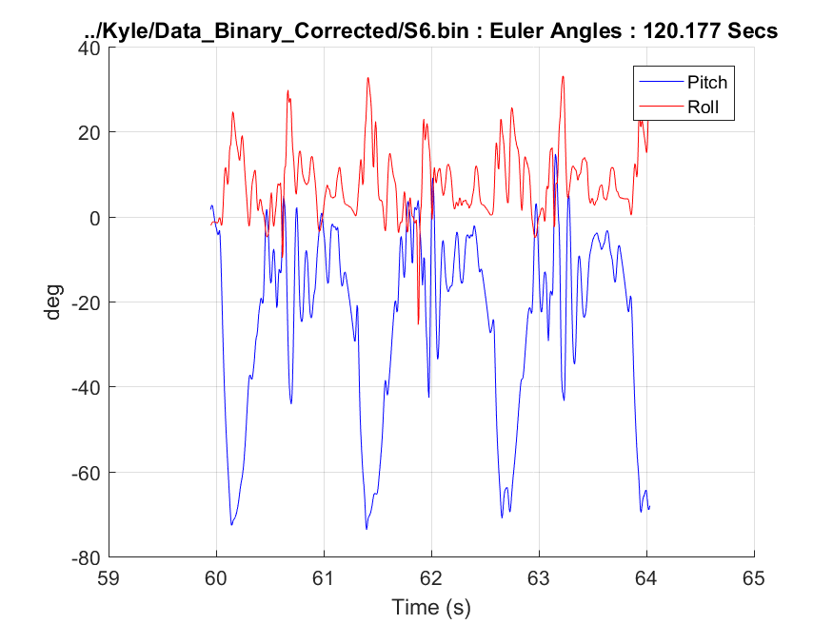  
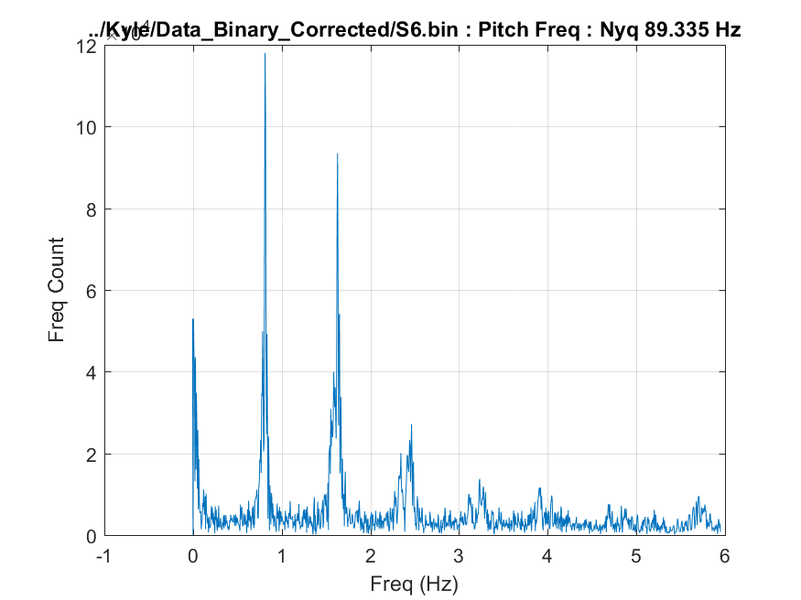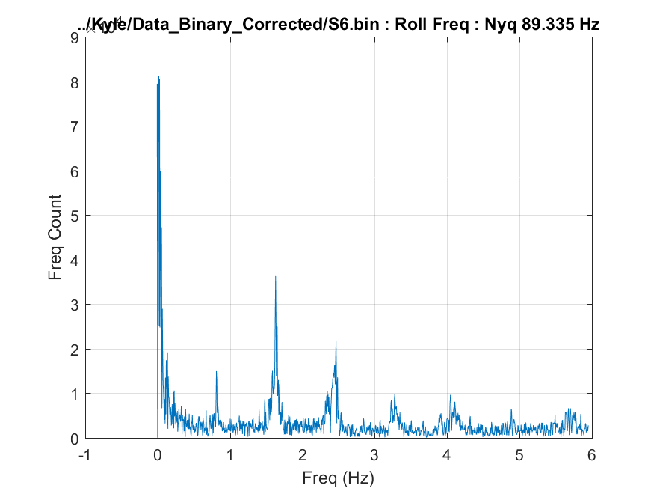**

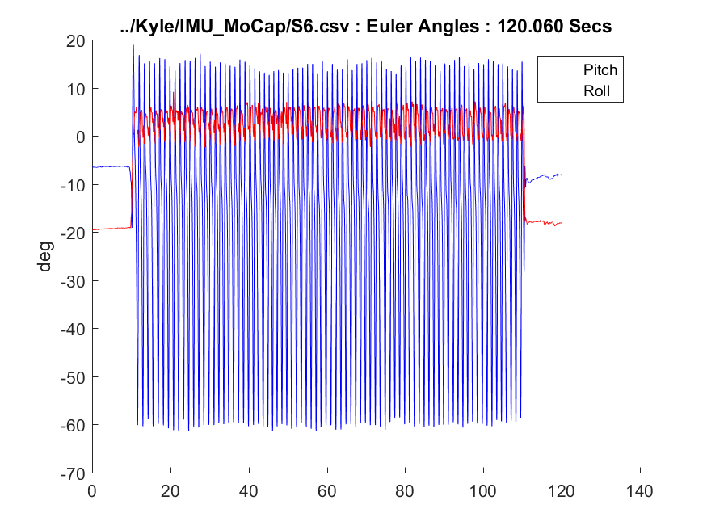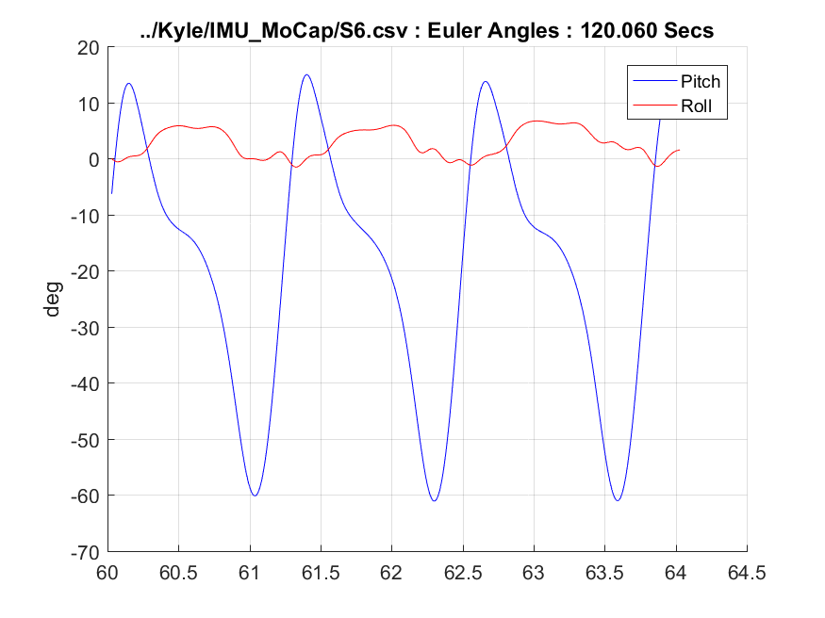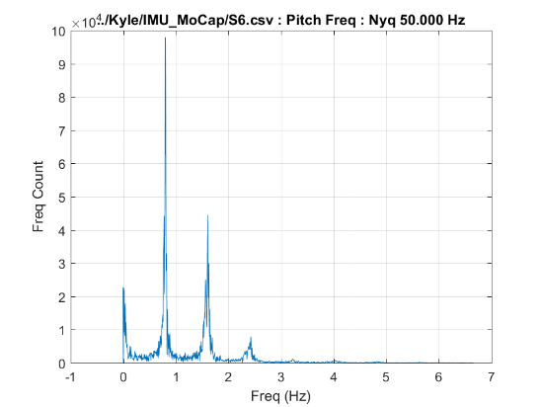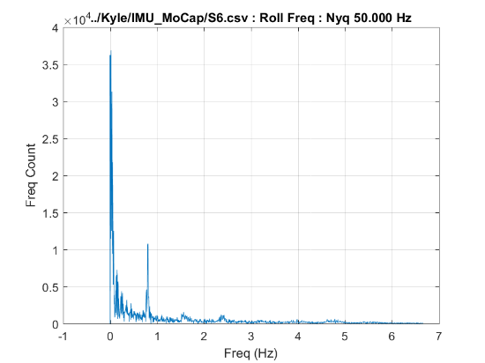

* 1. **Z1: Foot Mounted, 1.8 MPH, 15% Incline**

**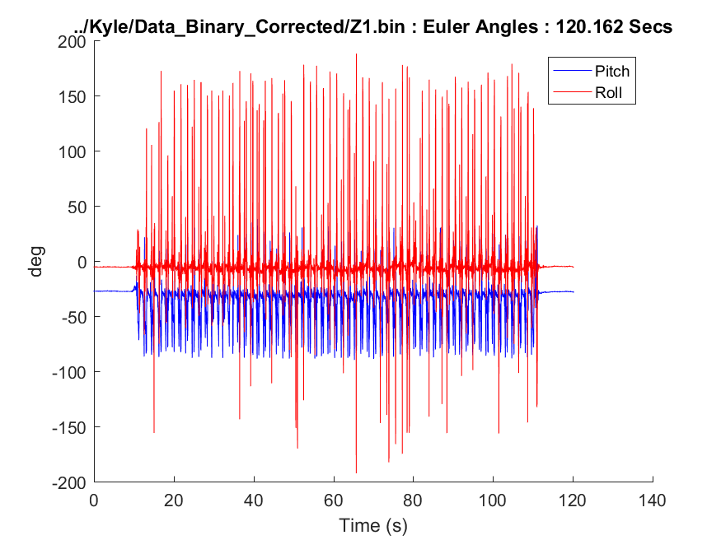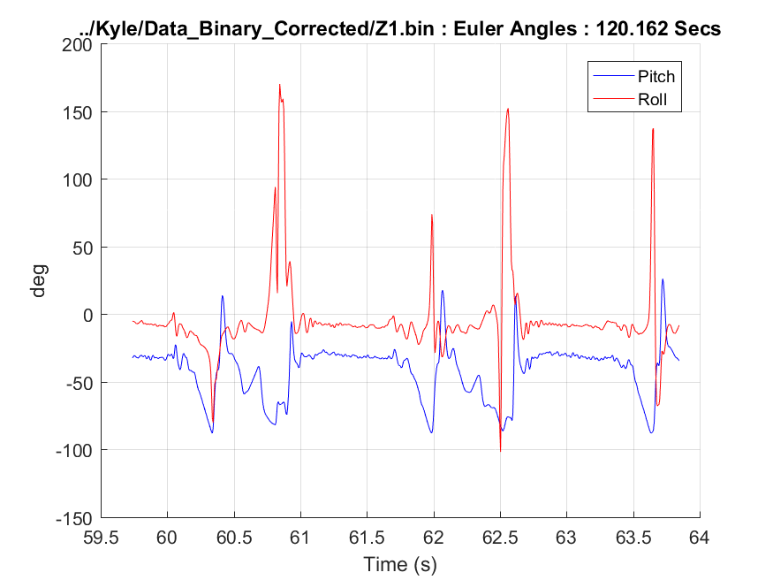  
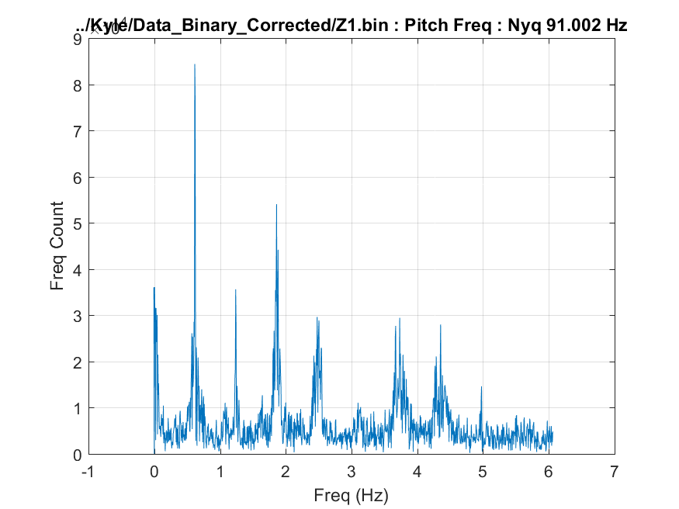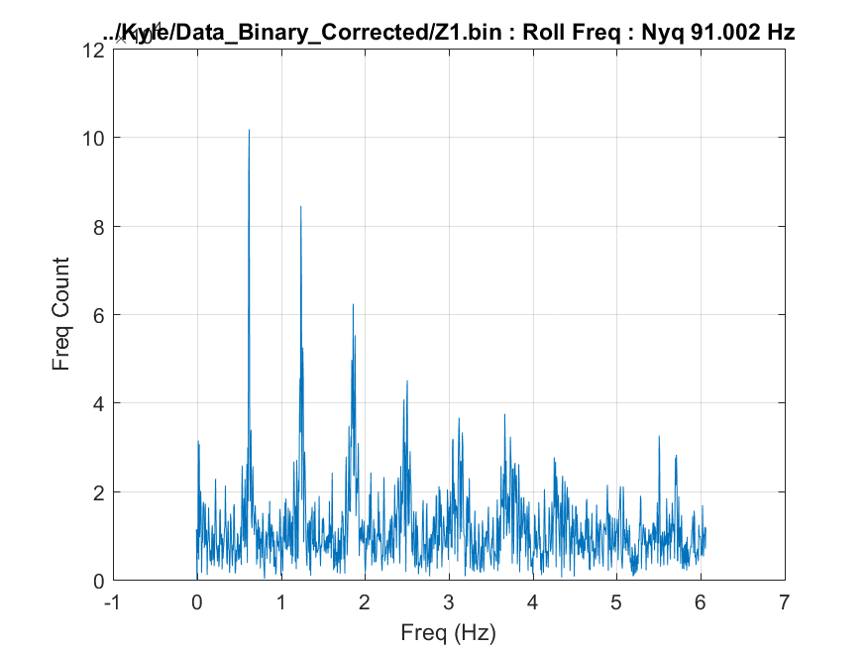**

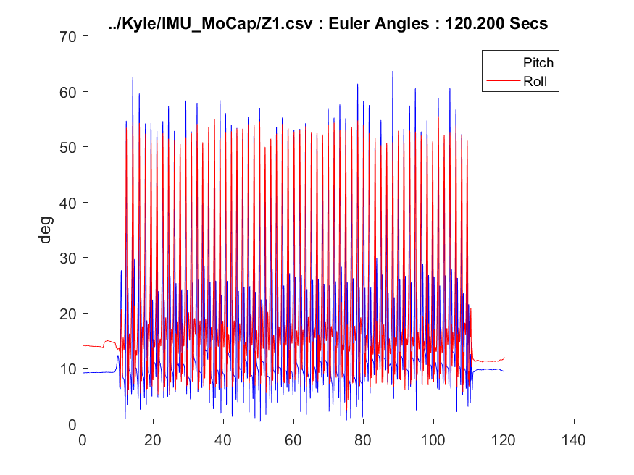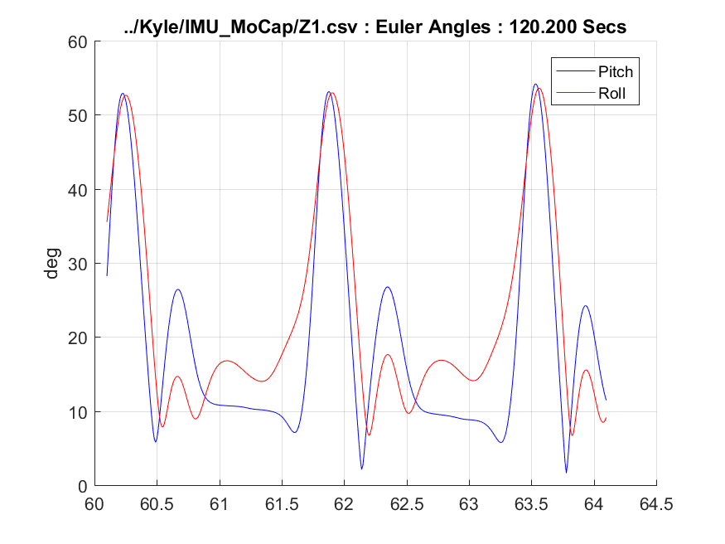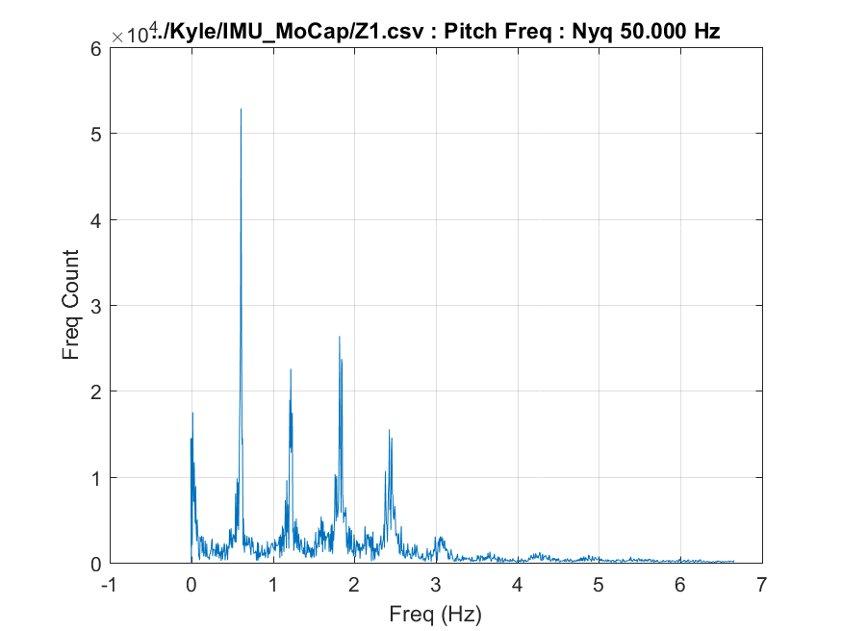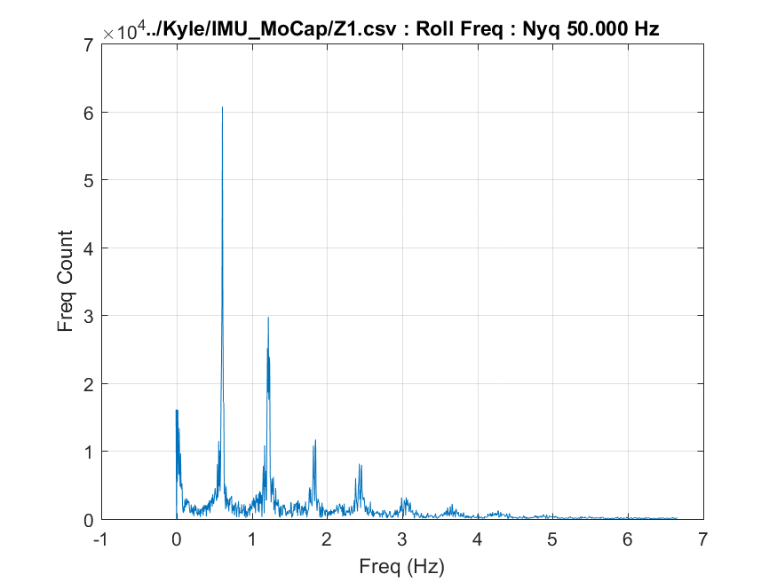

* 1. **Z2: Foot Mounted, 2.7 MPH, 15% Incline**

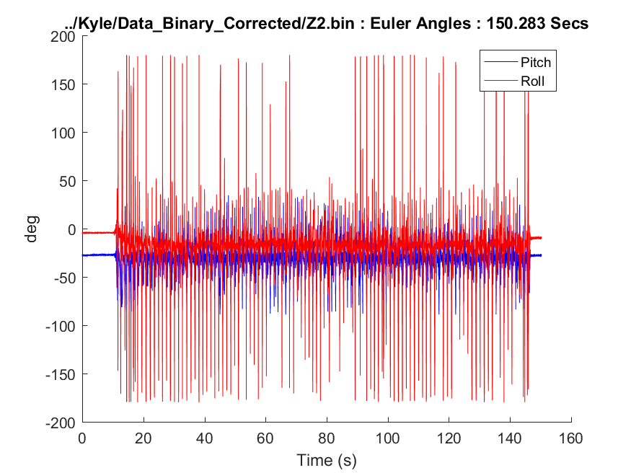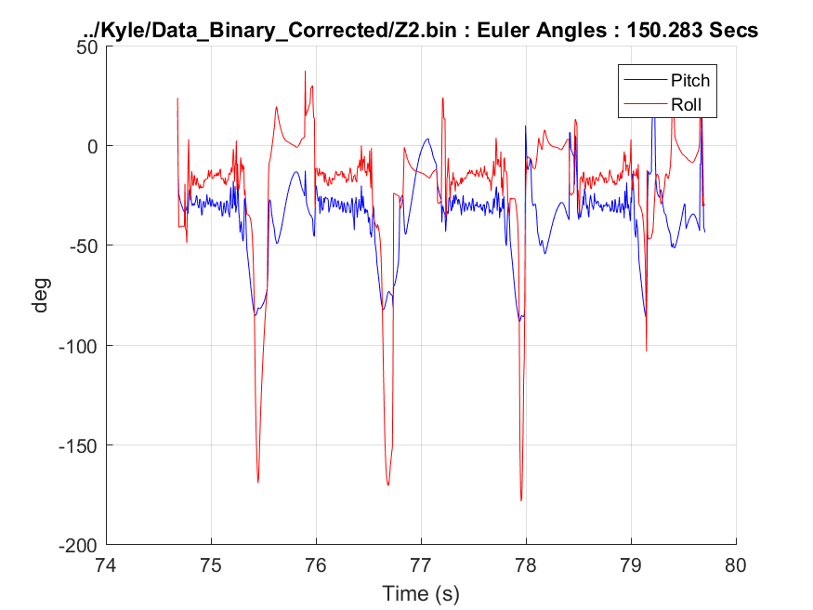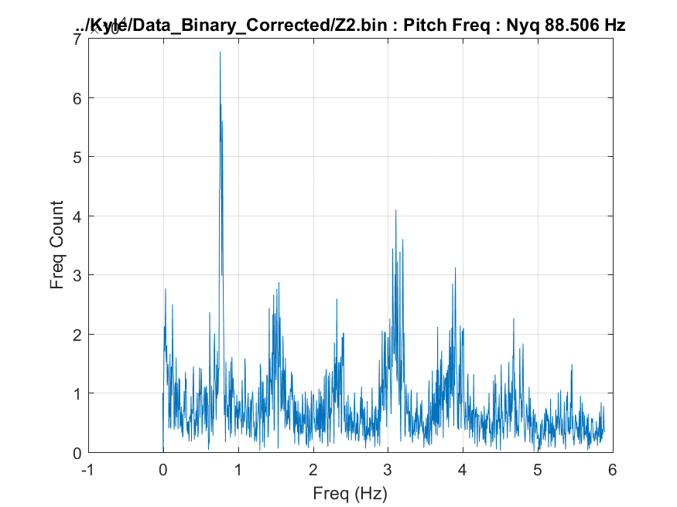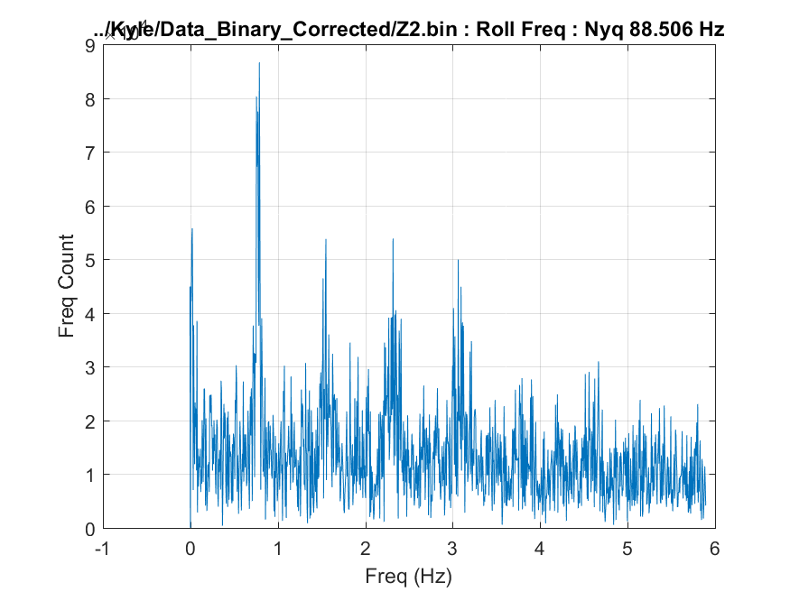

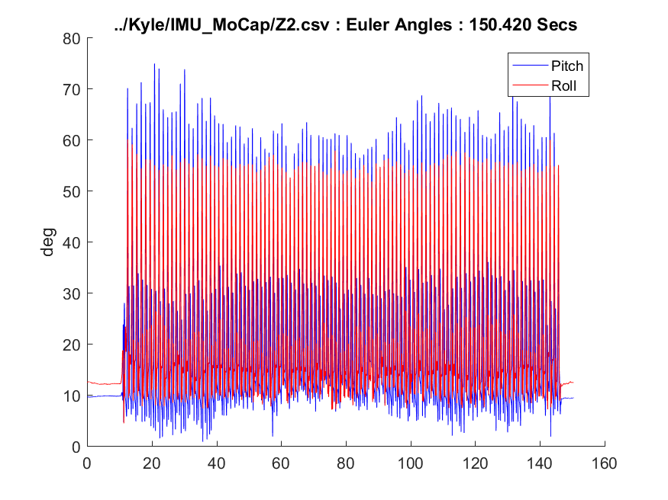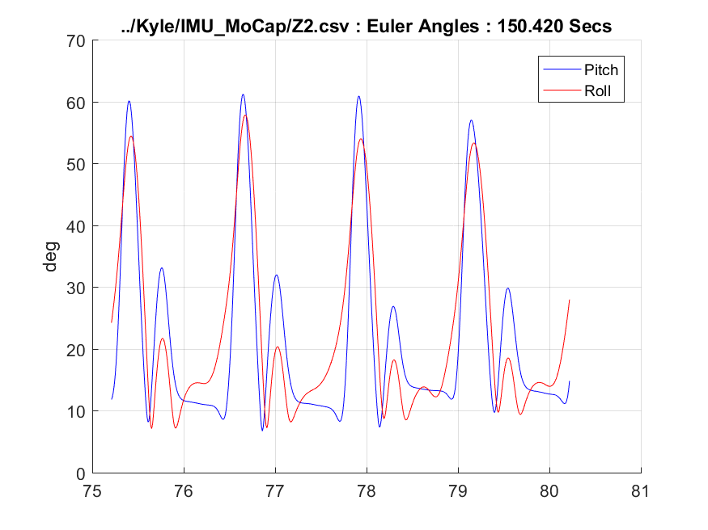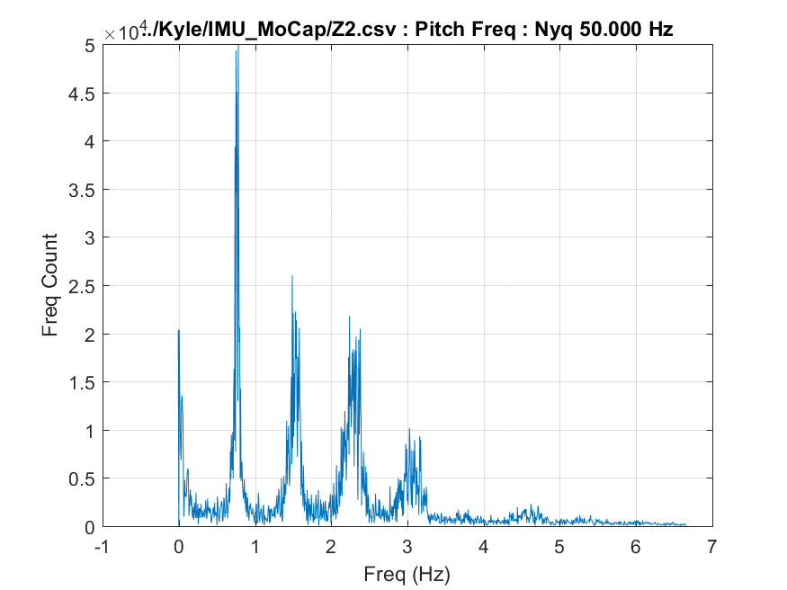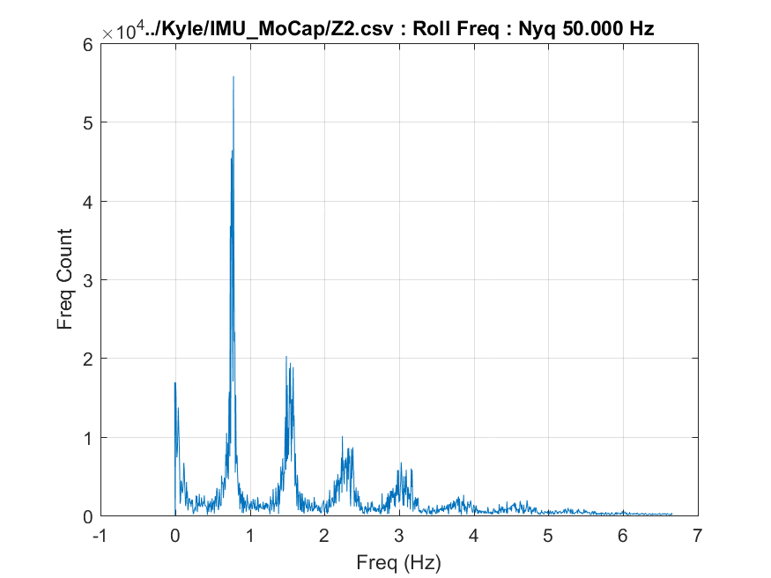

* 1. **Z3: Foot Mounted, 1.8 MPH, 0% Incline**

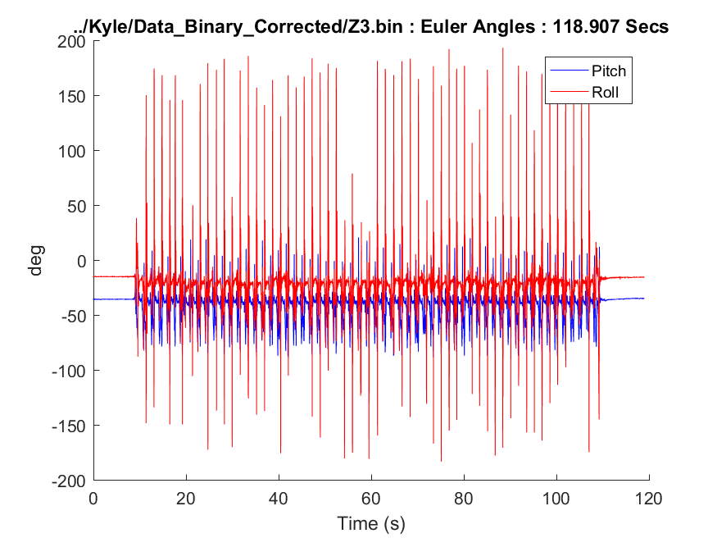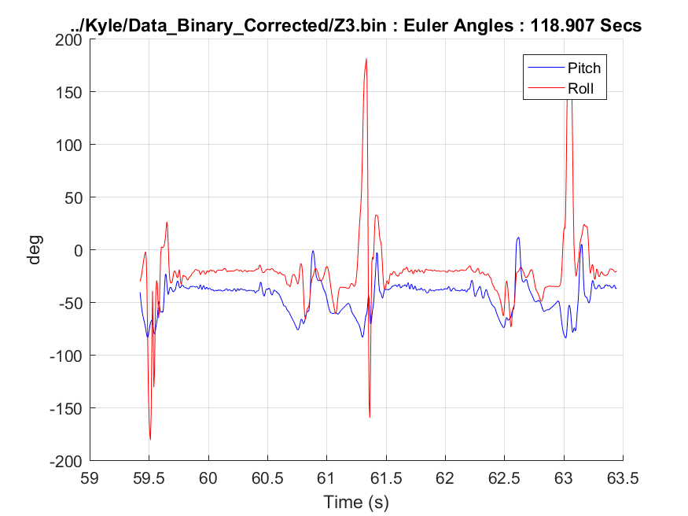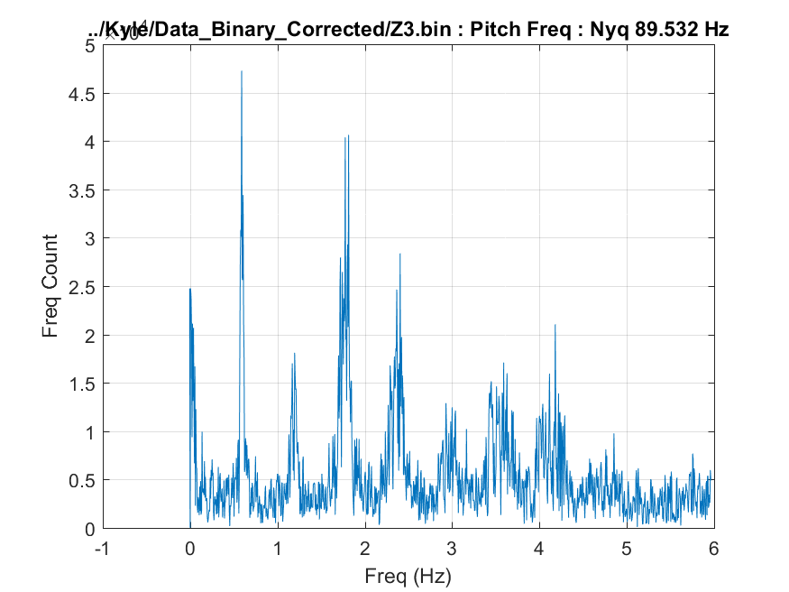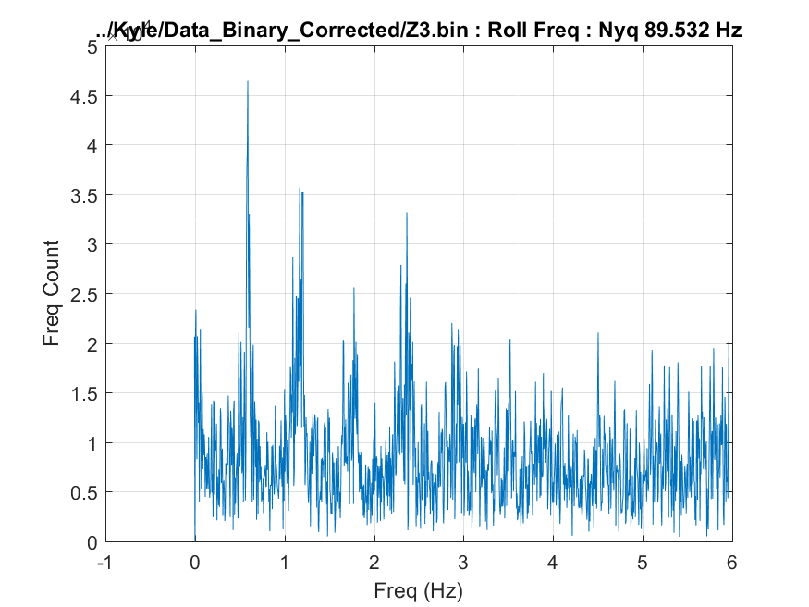

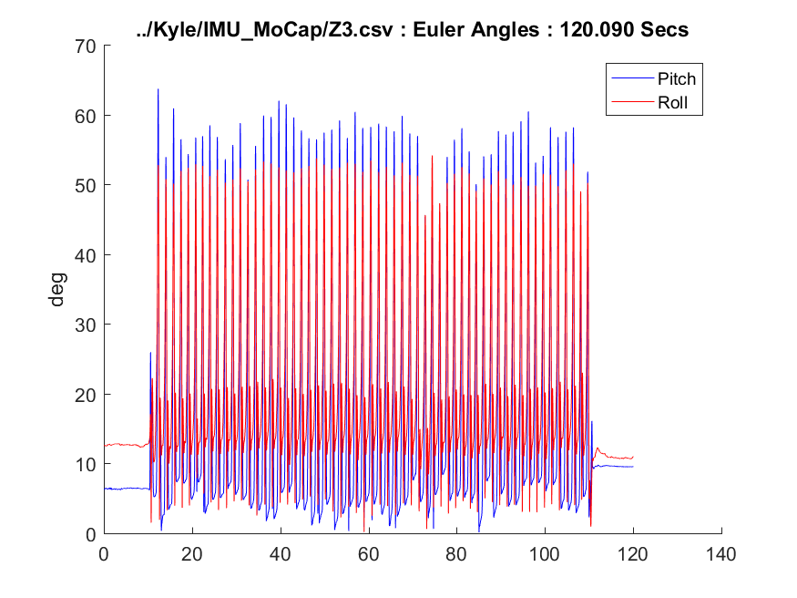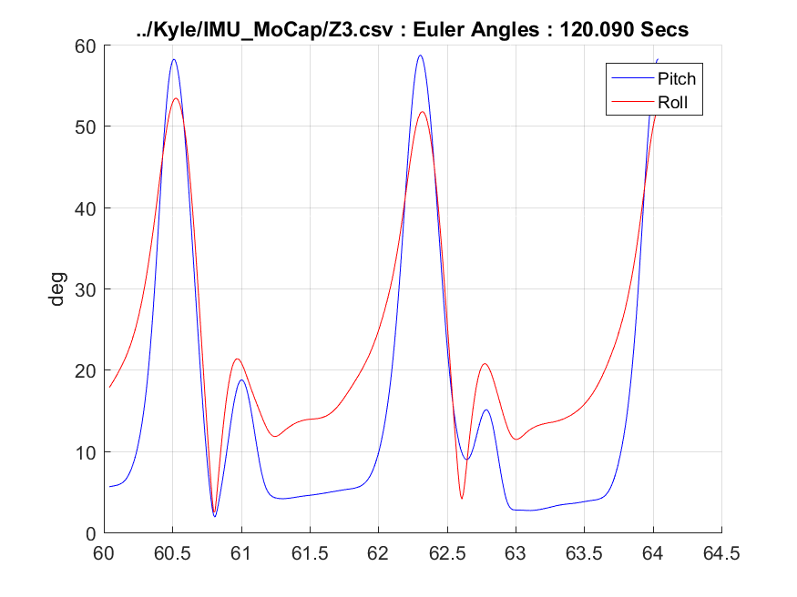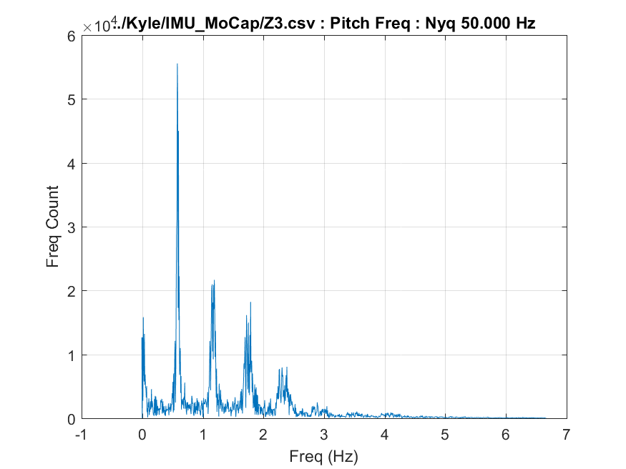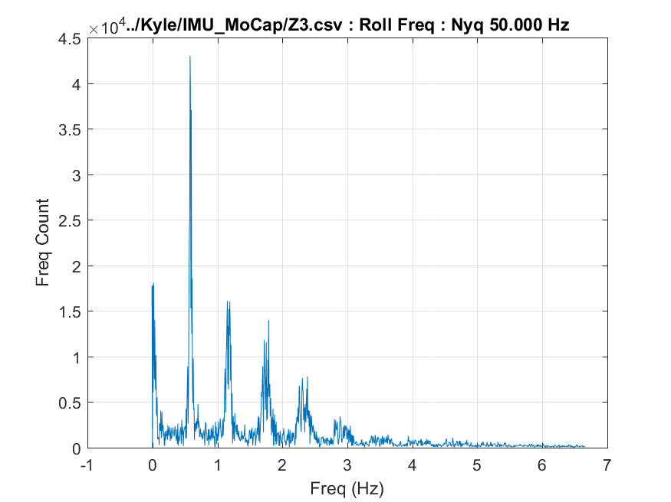

* 1. **Z4: Foot Mounted, 2.7 MPH, 0% Incline**

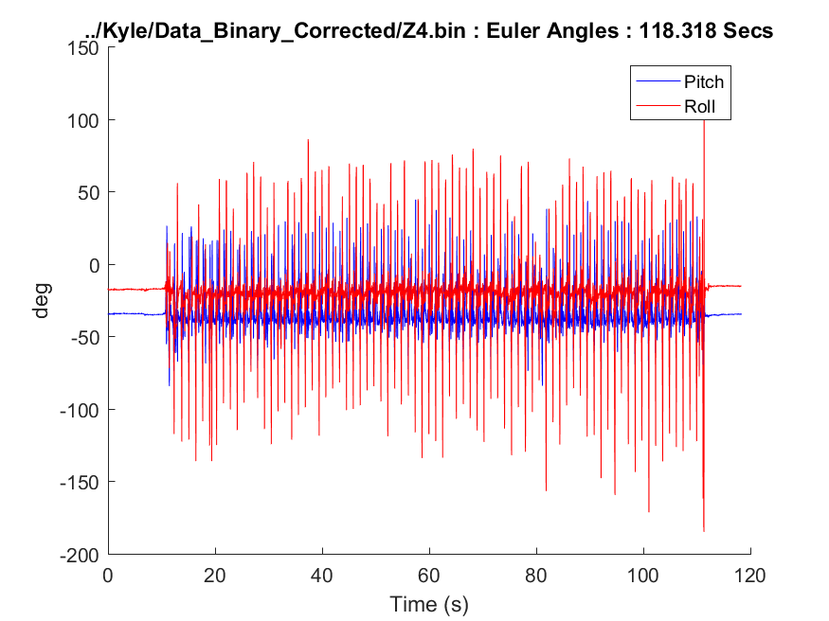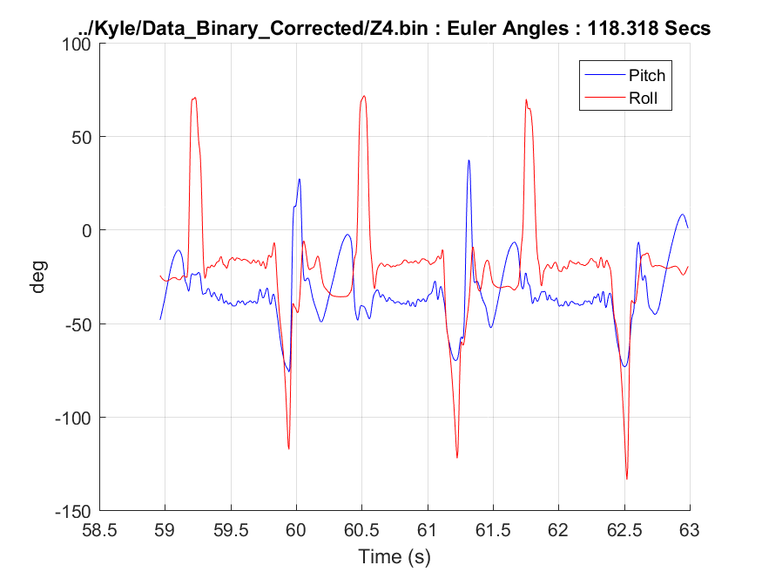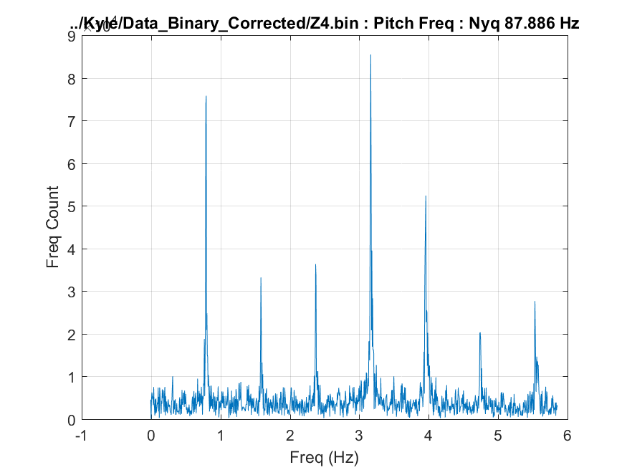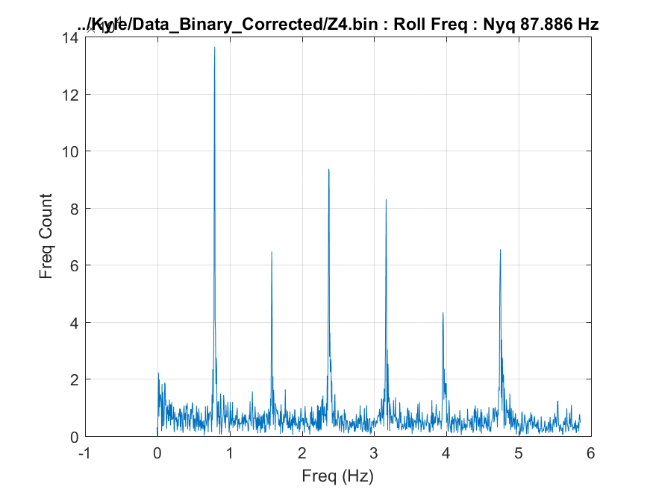

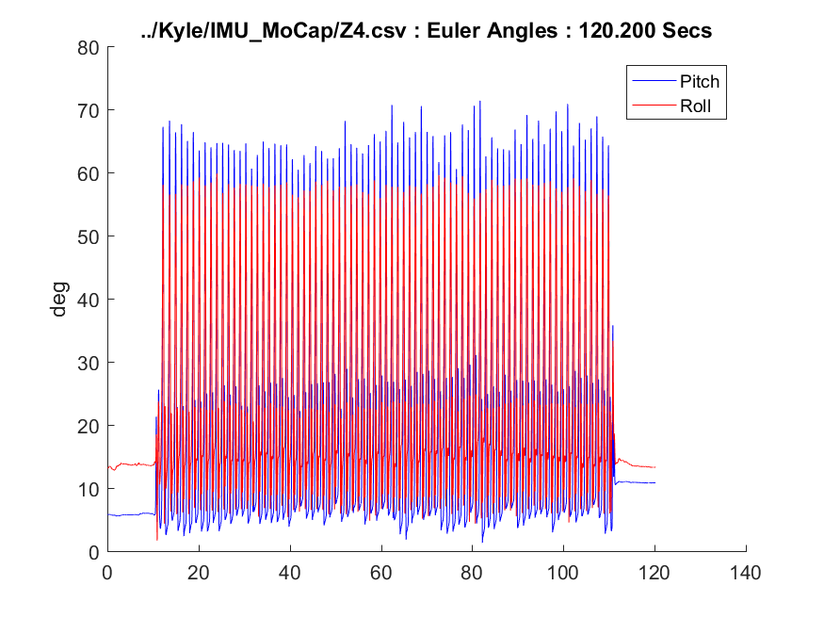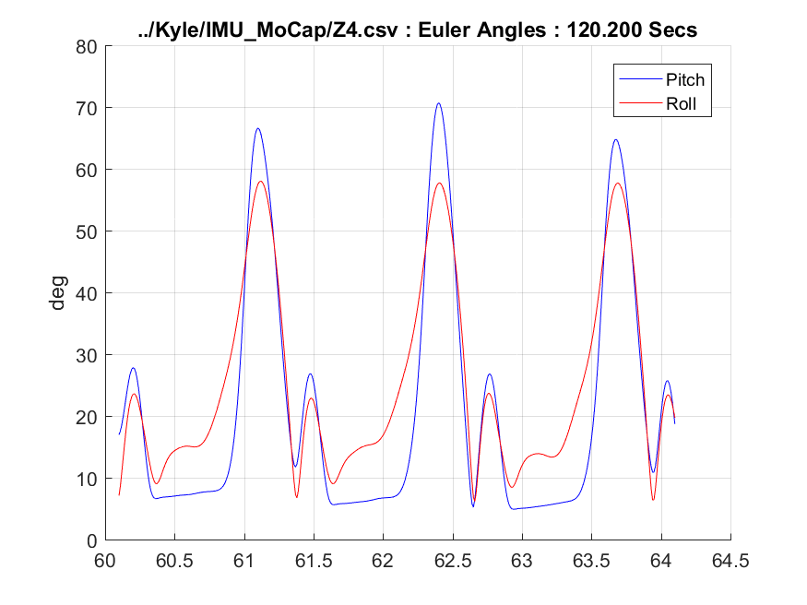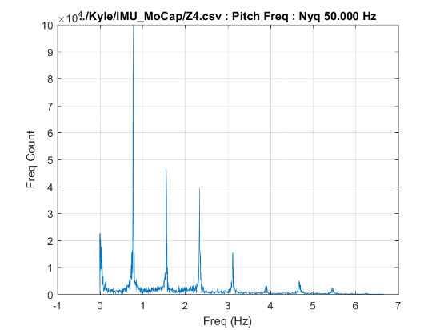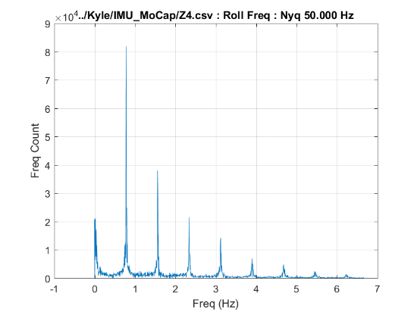

* 1. **Z5: Foot Mounted, 1.8 MPH, -3% Incline**

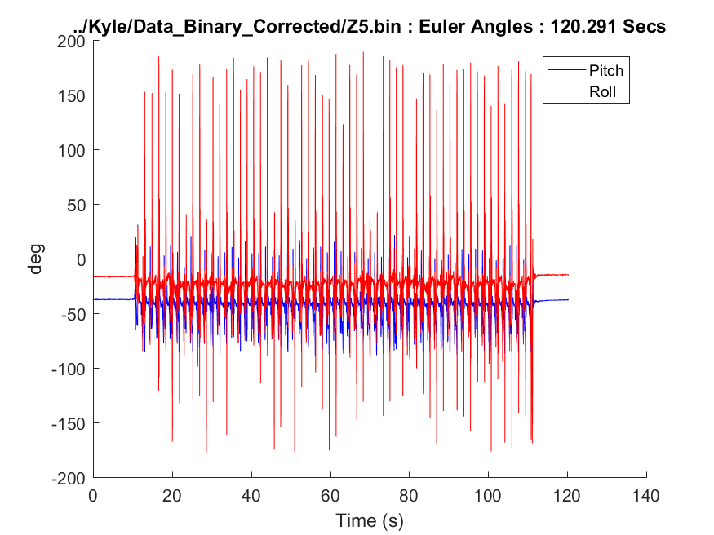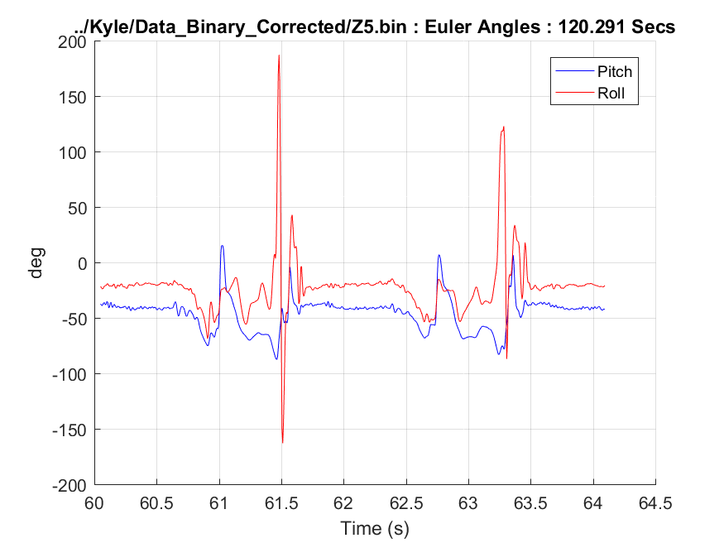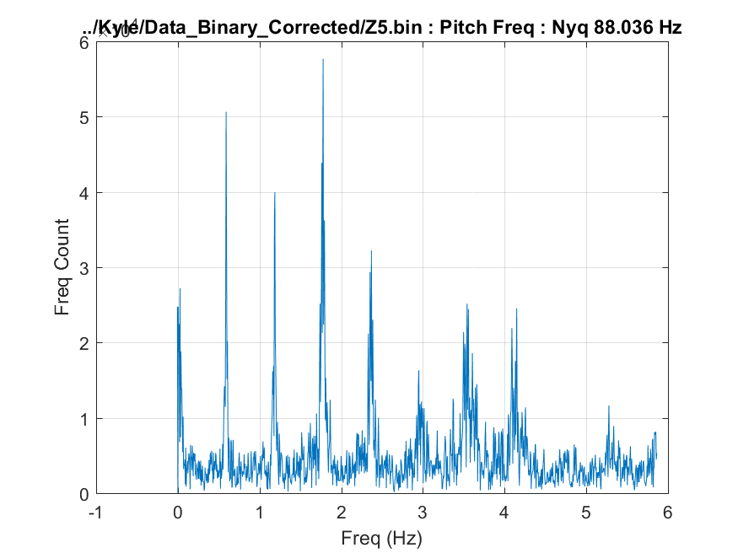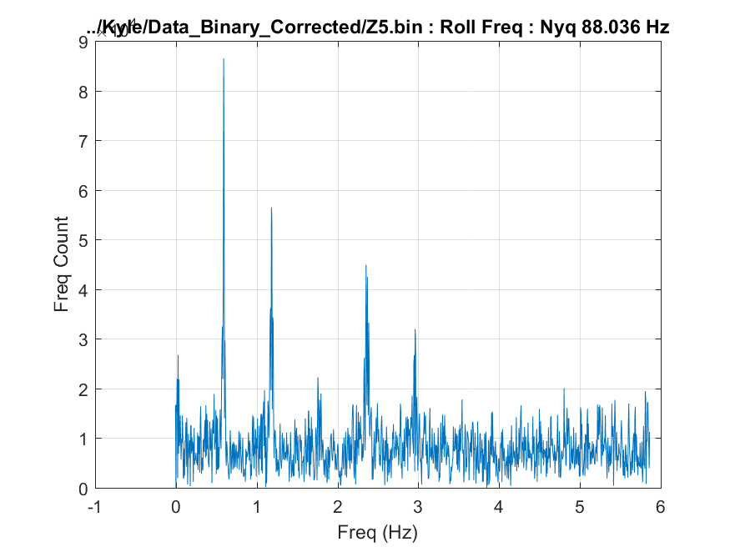

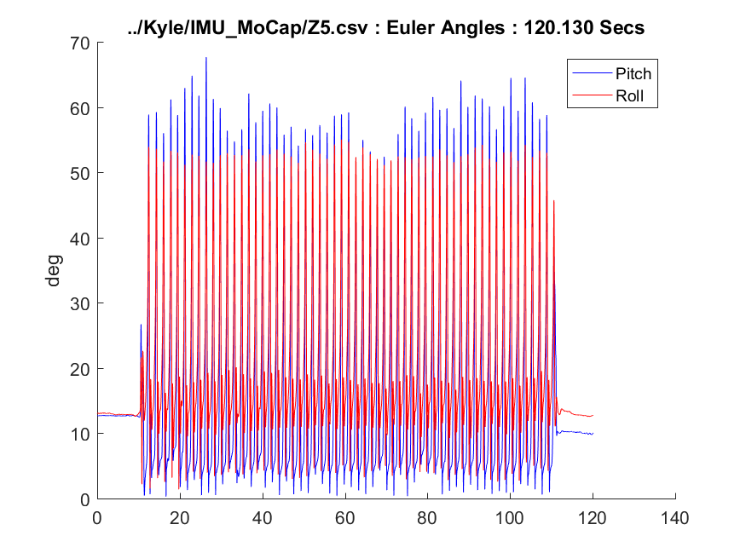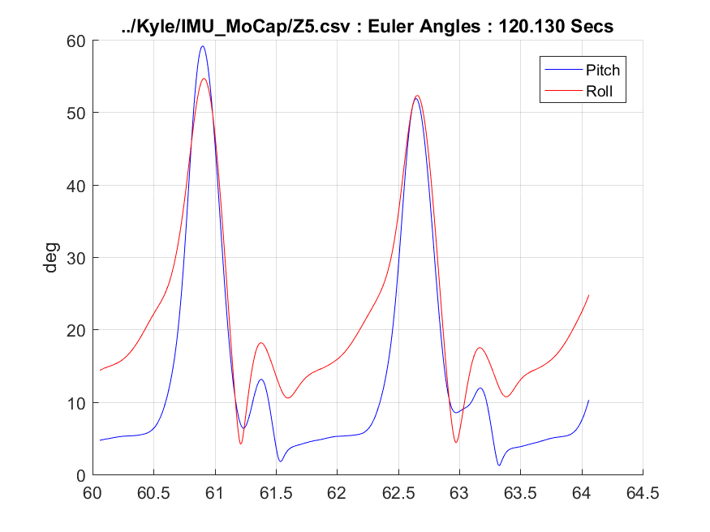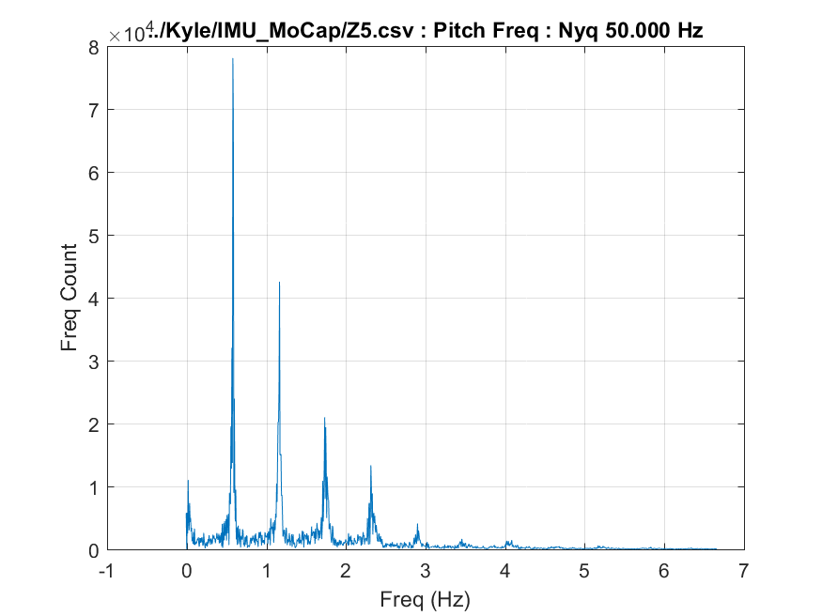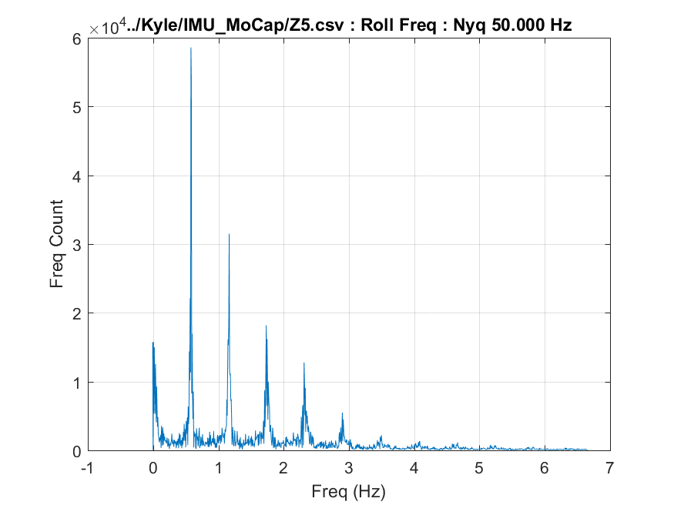

* 1. **Z6: Foot Mounted, 2.7 MPH, -3% Incline**

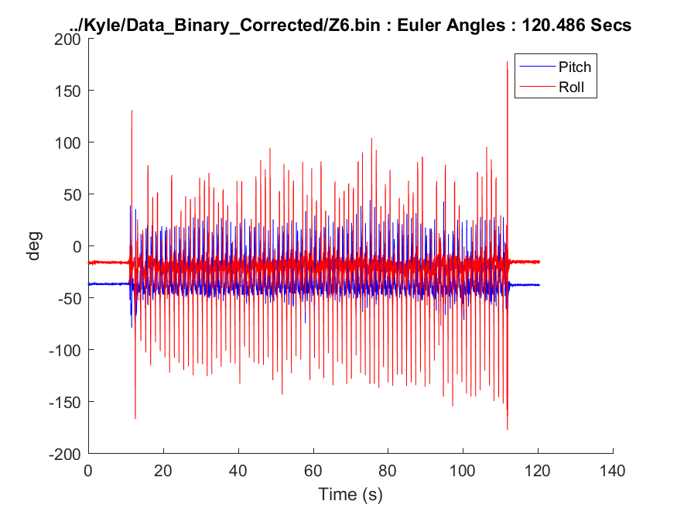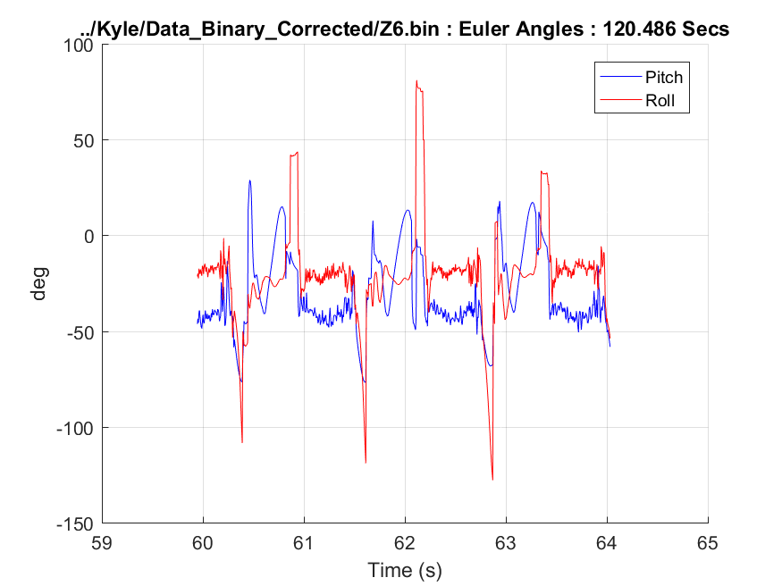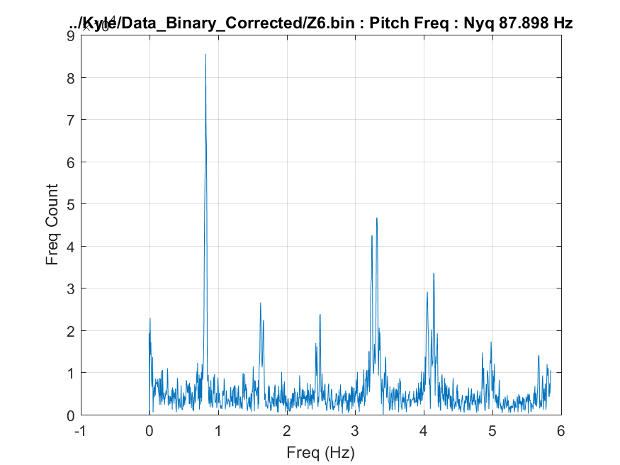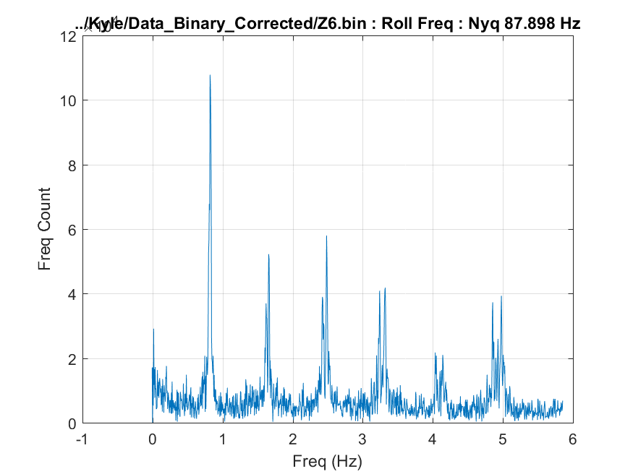

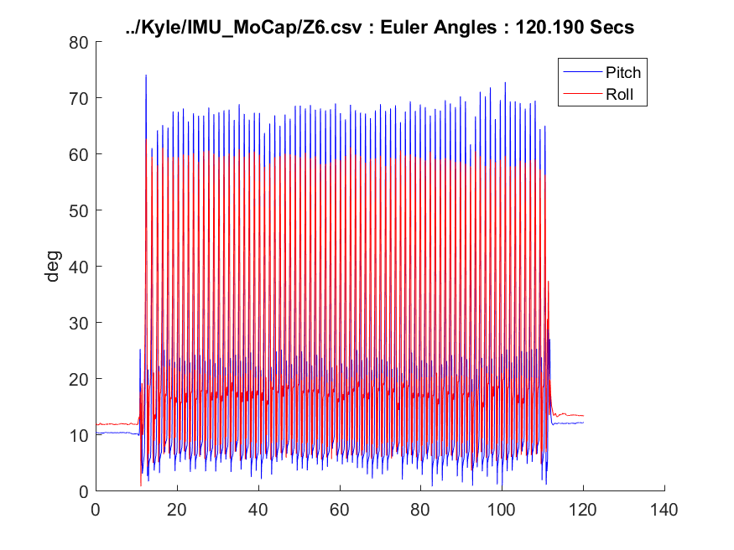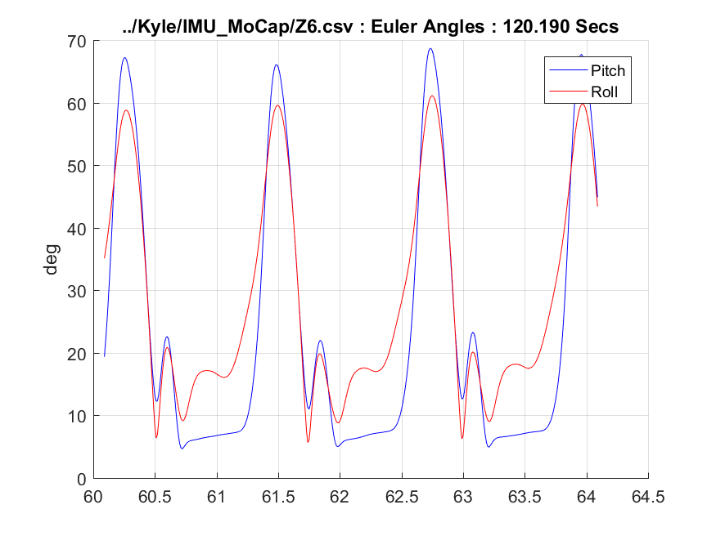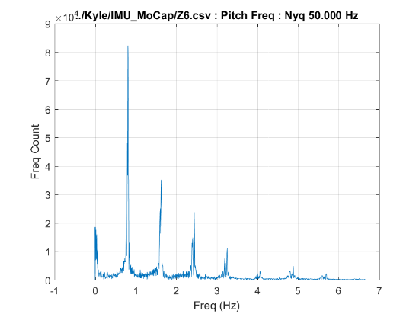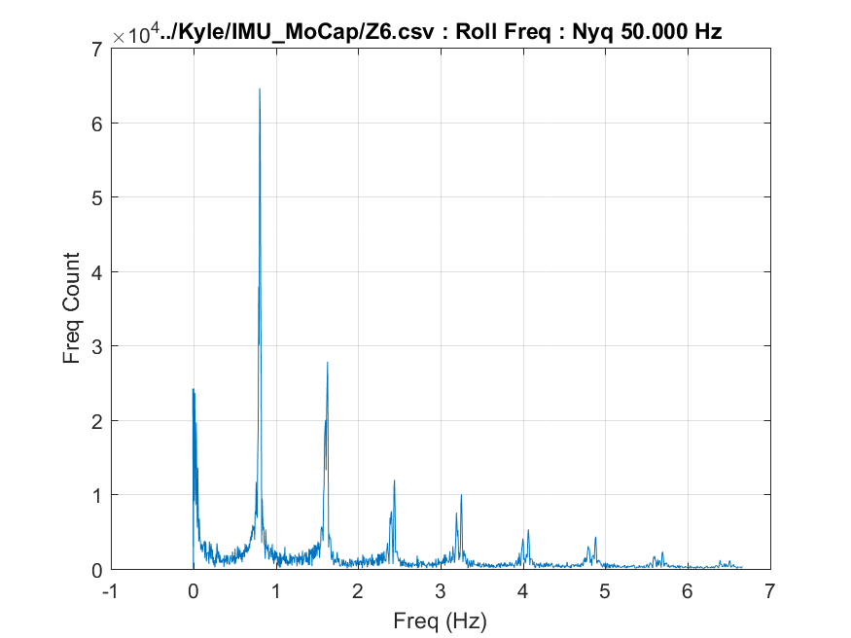

**Addendum I: IMU plate Vicom Reflector Placements**

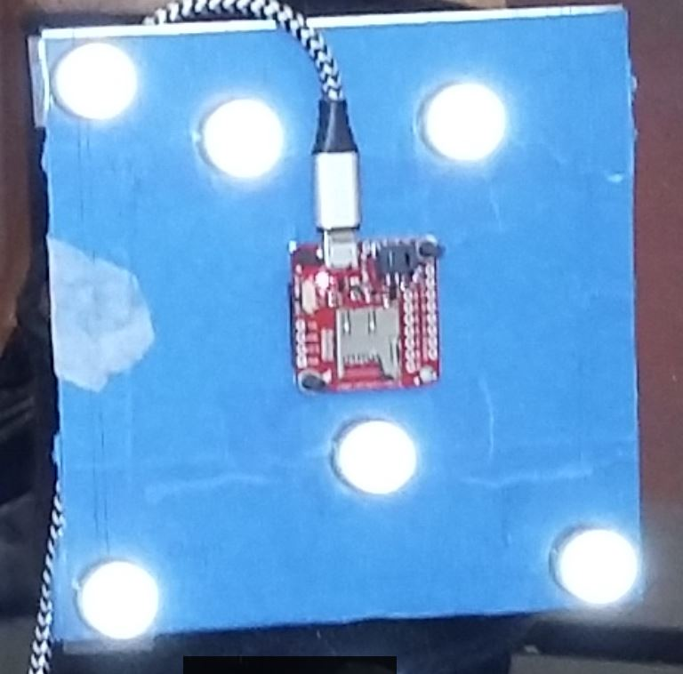

**Center2**

**Center3**

**Primary**

**Secondary**

**Origin**

**Center1**

**Addendum II: Left Leg, Vicom Reflector Placements**

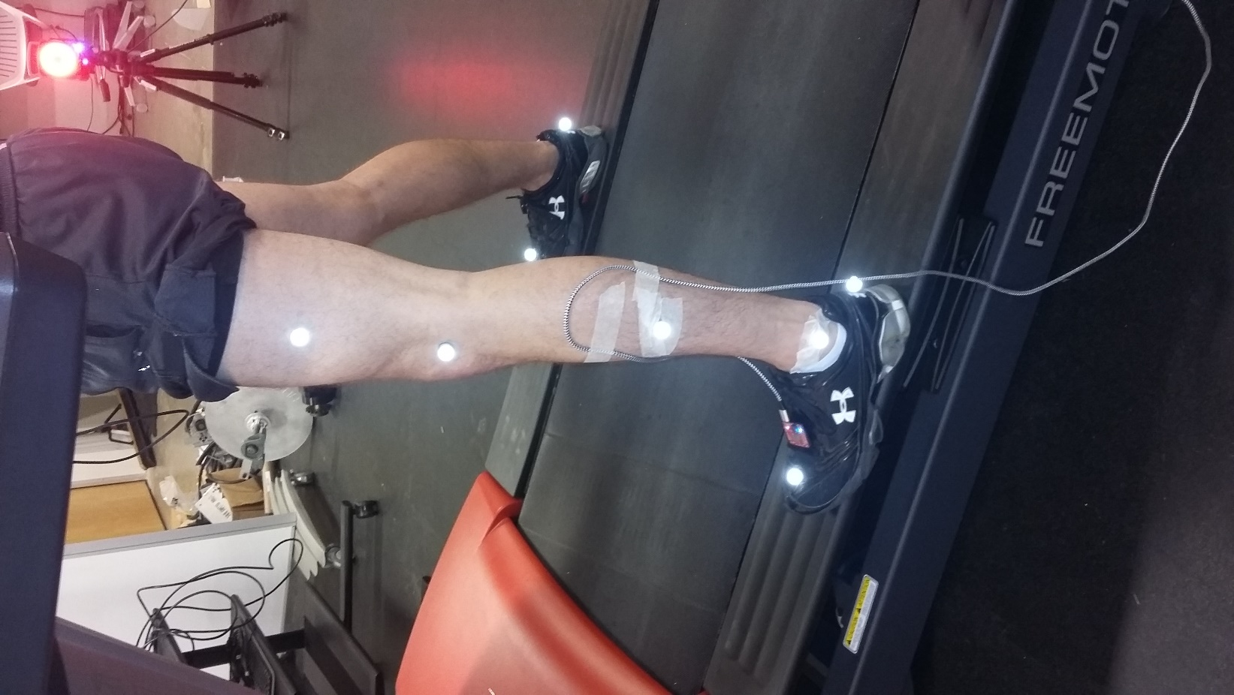

**Y**

**X**

**Z**

**LTHI**

**LKNE**

**LTIB**

**LANK**

**LHEE**

**LTOE**

**Addendum III: Left Leg, Femur (Thigh) Mount – “F”**

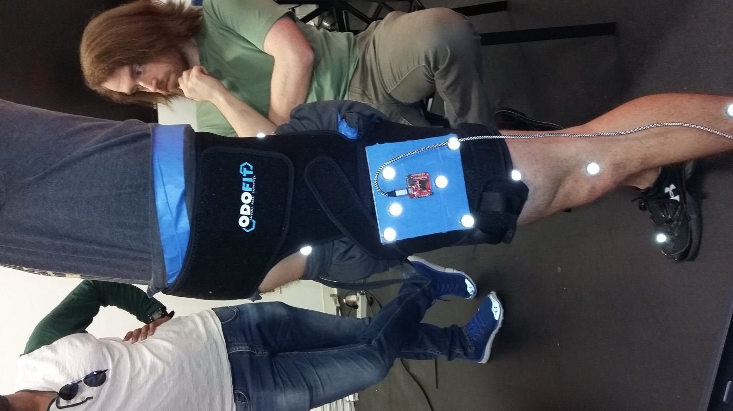

**Addendum IV: Left Leg, Shank Mount – “S”**

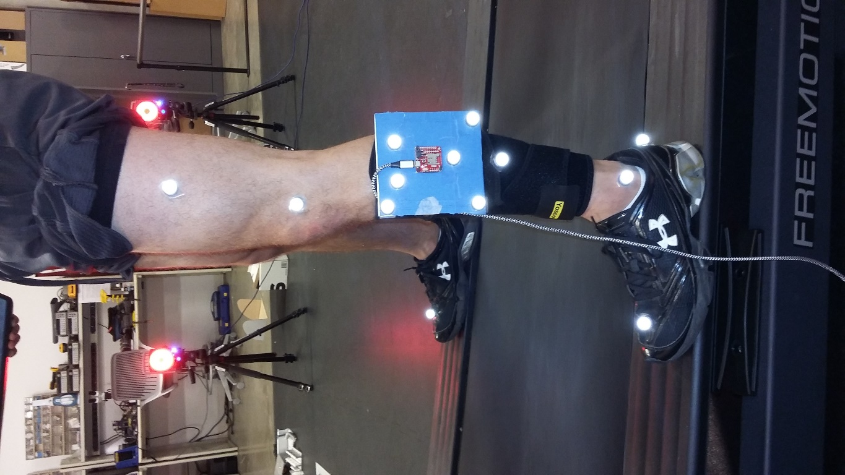 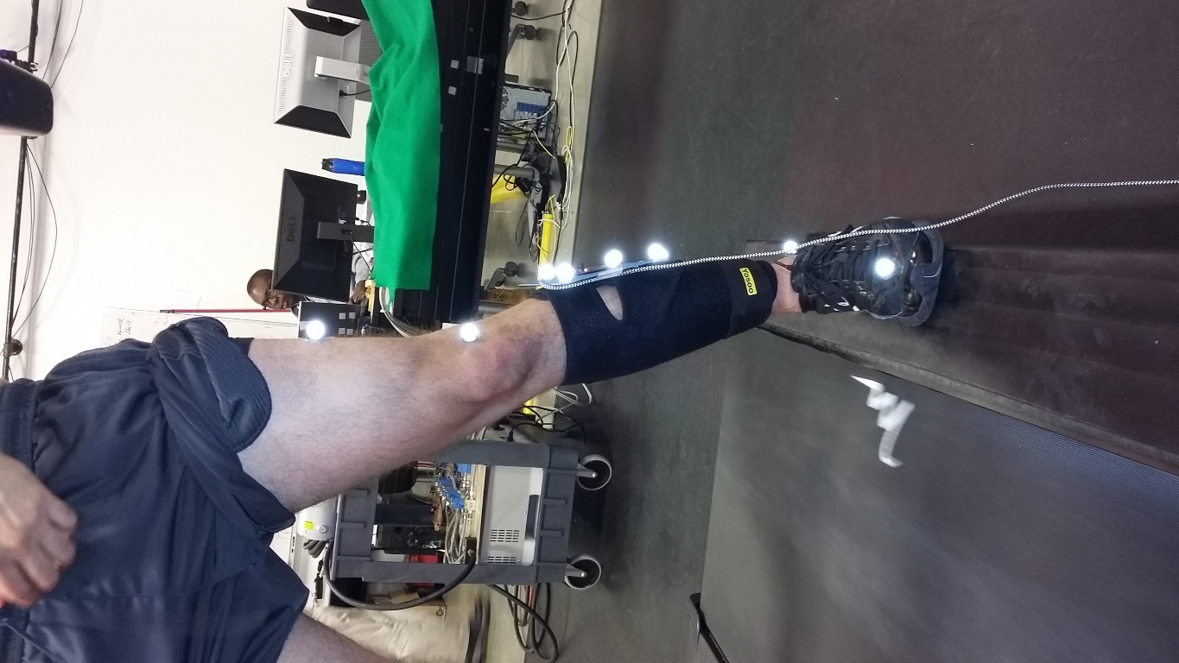

**Addendum V: Left Leg, Foot Mount – “Z”**

